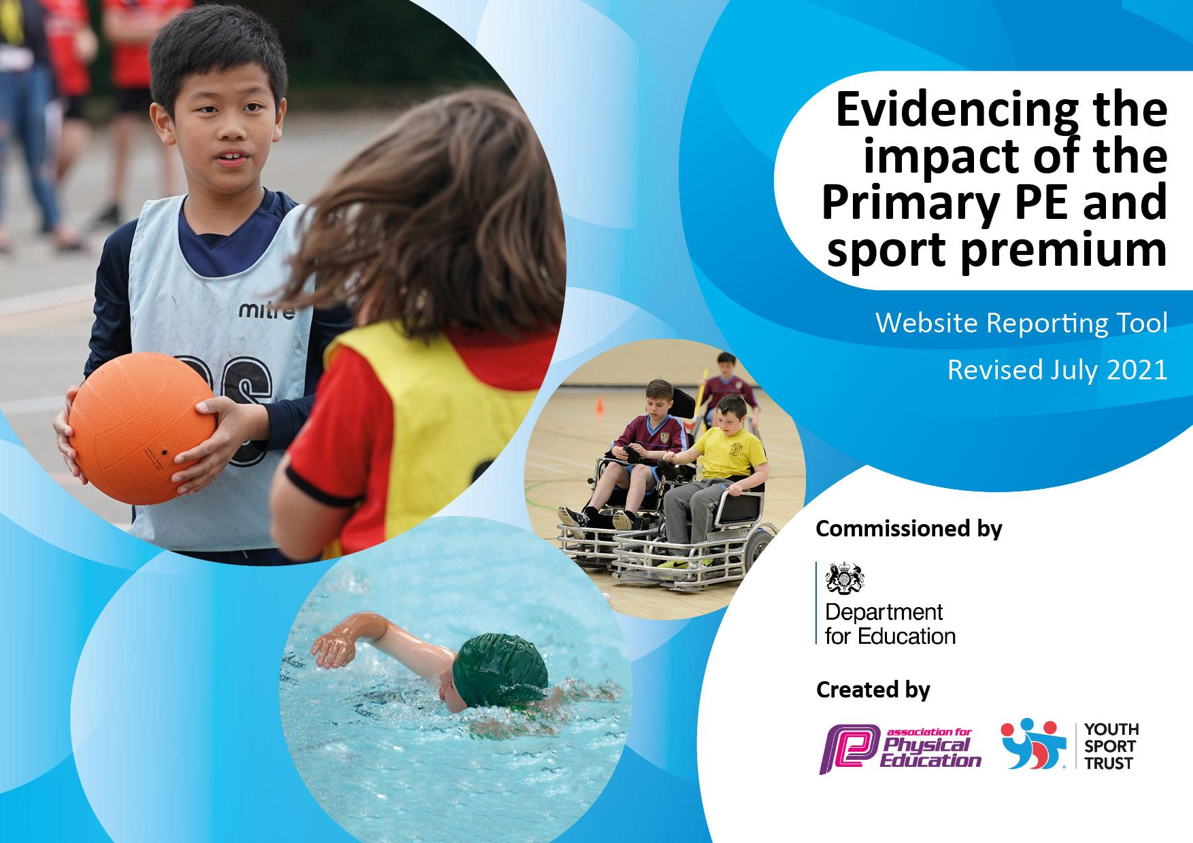
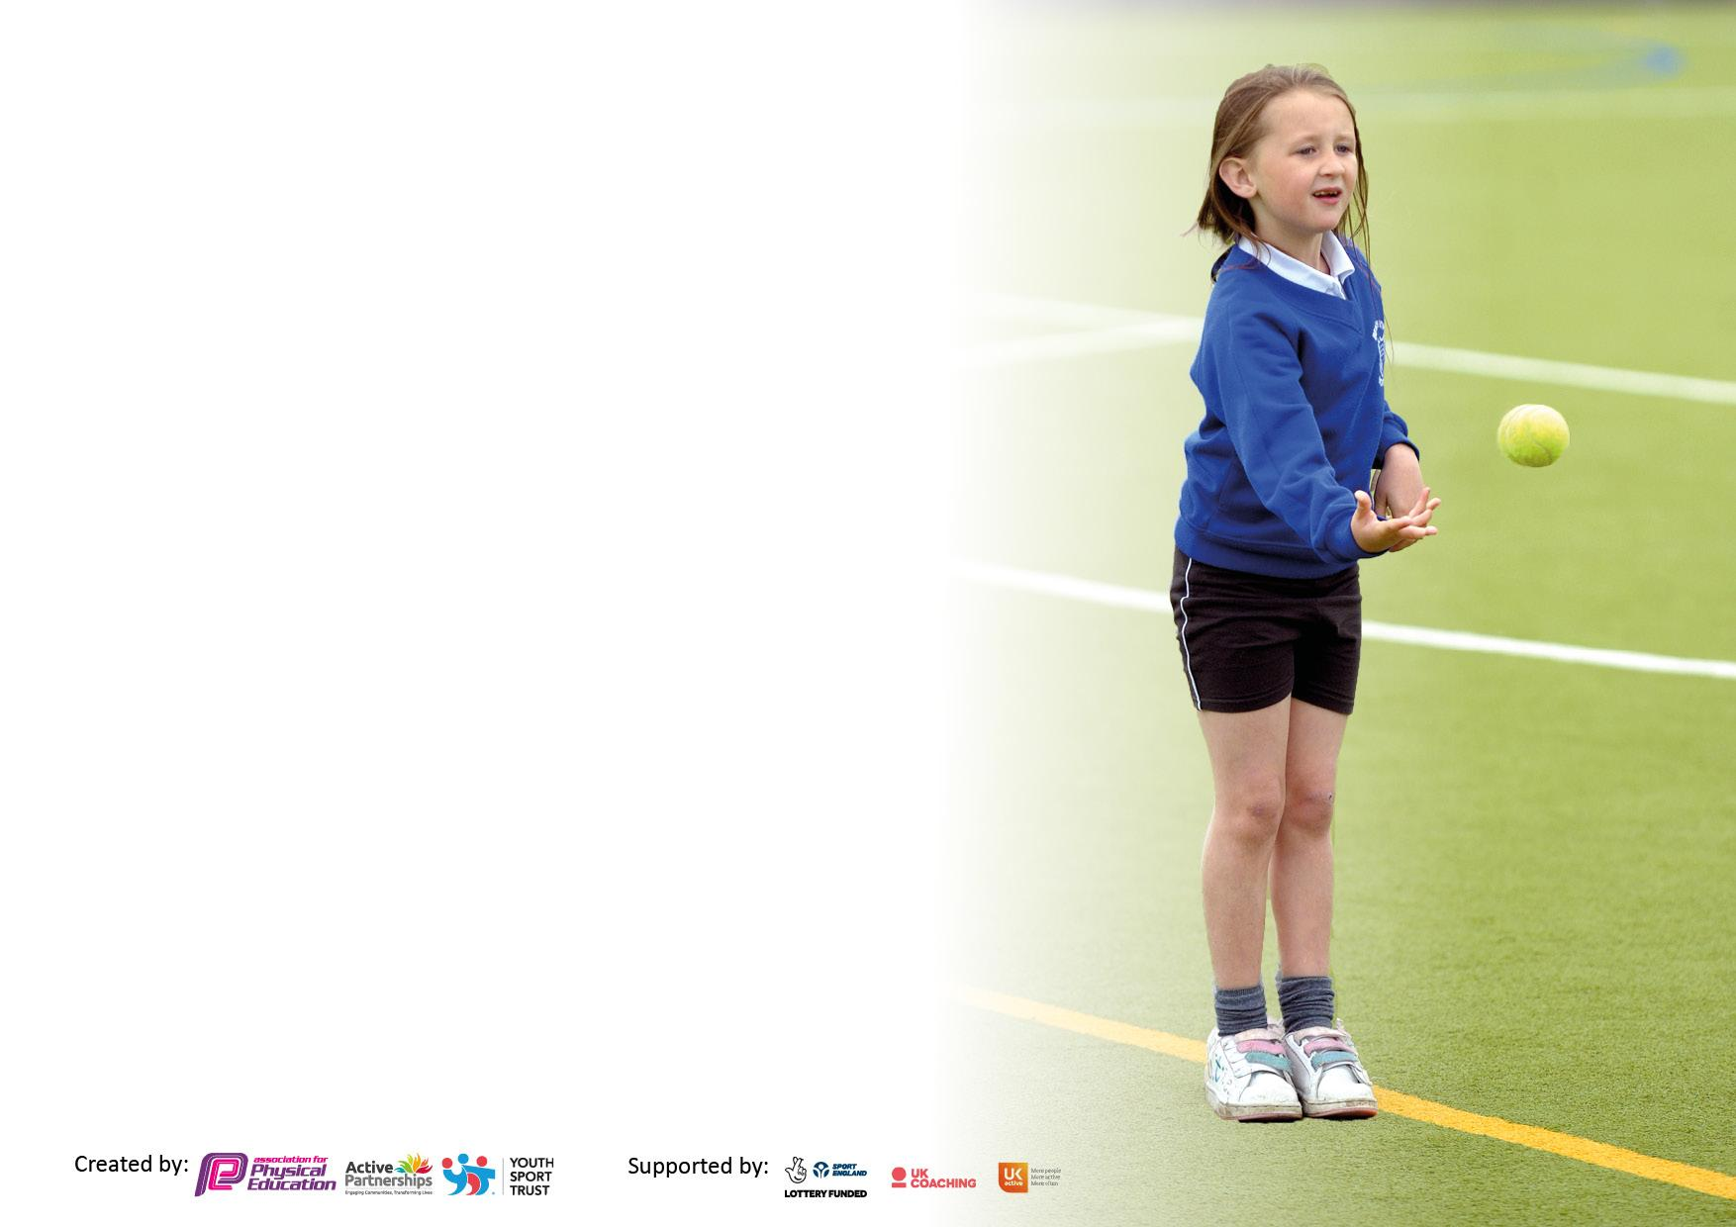

It is important that your grant is used effectively and based on school need. The Education Inspection Framework makes clear there will be a focus on ‘whether leaders and those responsible for governors all understand their respective roles and perform these in a way that enhances the effectiveness of the school’.

Under the Quality of Education Ofsted inspectors consider:
Intent - Curriculum design, coverage and appropriateness
Implementation - Curriculum delivery, Teaching (pedagogy) and Assessment
Impact - Attainment and progress

To assist schools with common transferable language this template has been developed to utilise the same three headings which should make your plans easily transferable between working documents.

Schools must use the funding to make additional and sustainable improvements to the quality of Physical Education, School Sport and Physical Activity (PESSPA) they offer. This means that you should use the Primary PE and sport premium to:

- Develop or add to the PESSPA activities that your school already offer
- Build capacity and capability within the school to ensure that improvements made now will benefit pupils joining the school in future years
- The Primary PE and sport premium should not be used to fund capital spend projects; the school’s budget should fund these.

Pleasevisitgov.ukfortherevisedDfEguidanceincludingthe5keyindicatorsacrosswhichschoolsshoulddemonstrate animprovement.Thisdocumentwillhelpyoutoreviewyourprovisionandtoreportyourspend.DfEencouragesschools to use this template as an effective way of meeting the reporting requirements of the Primary PE and sport premium.

We recommend you start by reflecting on the impact of current provision and reviewing the previous spend.

Schools are required to publish details of how they spend this funding, including any under-spend from 2019/2020, as well as on the impact it has on pupils’ PE and sport participation and attainment. All funding must be spent by 31st July 2022.

We recommend regularly updating the table and publishing it on your website throughout the year. This evidences your ongoing self-evaluation of how you are using the funding to secure maximum, sustainable impact. Final copy must be posted on your website by the end of the academic year and no later than the 31st July 2021. To see an example of how to complete the table please click HERE.
Created by: Supported by:

Details with regard to funding
Please complete the table below.

Total amount carried over from 2021/22 | £0.00
Total amount allocated for 2022/23 | £17,710
How much (if any) do you intend to carry over from this total fund into 2022/23? | £0.00
Total amount allocated for 2022/23 | £17,710
Total amount of funding for 2022/23. To be spent and reported on by 31st July 2023. | £17,908

Swimming Data
Please report on your Swimming Data below.

Meeting national curriculum requirements for swimming and water safety.

N.B. Complete this section to your best ability. For example you might have practised safe self-rescue techniques on dry land which you can then transfer to the pool when school swimming restarts.
Due to exceptional circumstances priority should be given to ensuring that pupils can perform safe self rescue even if they do not fully meet the first two requirements of the NC programme of study
What percentage of your current Year 6 cohort swim competently, confidently and proficiently over a distance of at least 25 metres?  N.B. Even though your pupils may swim in another year please report on their attainment on leaving primary school at the end of the summer term 2022.  Please see note above | 65%
What percentage of your current Year 6 cohort use a range of strokes effectively [for example, front crawl, backstroke and breaststroke]?  Please see note above | 63%
What percentage of your current Year 6 cohort perform safe self-rescue in different water-based situations? | 63%
Schools can choose to use the Primary PE and sport premium to provide additional provision for swimming but this must be for activity over and above the national curriculum requirements. Have you used it in this way? | No

Action Plan and Budget Tracking
Capture your intended annual spend against the 5 key indicators. Clarify the success criteria and evidence of impact that you intend to measure to evaluate for pupils today and for the future.

Academic Year: 2022-2023 | Total fund allocated: | Date Updated:
Key indicator 1: The engagement of all pupils in regular physical activity – Chief Medical Officers guidelines recommend that primary school pupils undertake at least 30 minutes of physical activity a day in school |  |  |  | Percentage of total allocation:
 |  |  |  | %
Intent | Implementation |  | Impact
School focus: | Actions to achieve: | Funding allocated: | Evidence of impact: | Sustainability and suggested next steps:
Ensure that all pupils have access to extra curricular clubs helping their fitness and engagement in physical activity (PA) | Monitoring of pupils attendance through registers / teacher / TA data. | £5,000.00 | Pupil / coach / Teacher / TA feedback of engagement and enjoyment of activities | Resources/ equipment archived  And teachers / TAs trained are able to continue activities.
To ensure all children are engaging in physical activity on a daily basis outside of curriculum time | Lunch time staff to run one sporting activity, freeing up other staff member to organise other sporting zones |  | Increased engagement in organised sport during lunch times:  ● A wider range of sporting opportunities at lunch time - football, basketball, cricket  ● Positive pupil and teaching & learning assistant feedback | Build relationships with lunch time staff to embed this into our provision  Next steps:  ● Regular monitoring of the effectiveness of this new initiative  ● Feedback from pupils and staff taken to ensure it is purposeful  ● Continue to invest in break and lunch time resources- looking into community offers.
Key indicator 2: The profile of PESSPA being raised across the school as a tool for whole school improvement |  |  |  | Percentage of total allocation:
 |  |  |  | %
Intent | Implementation |  | Impact
School focus: | Actions to achieve: | Funding allocated: | Evidence of impact: | Sustainability and suggested next steps:
Galvanise pupil and teacher interest and engagement with PESSA. | PESSPA Display board. Including all 3 areas. Regularly update with photos.  Use celebration assemblies for PESSPA good work | £800.00 | Higher interest, engagement, and attainment across all PESSPA activities. Pupils voice, teacher feedback | Ensure that both the display board and assemblies are refreshed and sustained as PESSPA policy
To enhance the curriculum offer through enrichment competitions and specialist training which are celebrated | Secure outside professional sports coaches to deliver a wide variety of enrichment | Sports specialists included in PE SLA with Local Authority | Increased percentage of pupils, including reluctant and greater depth children, accessing specialist to foster talents and interests  ● Increased engagement in physical activity  ● Pupils accessing enrichment opportunities will develop the skills to represent the school at a competitive level  ● Whole school approach to announcing participation and celebrating whole school success | ● Specialist staff build relationships with children and parents through assemblies etc. and raise the profile of these activities  Next Steps:  ● Pupil survey to identify additional extracurricular activities not yet available at Pooles Park  ● Purchase trophies and medals for inter-house competitions  ● To provide further opportunities for higher achieving pupils

Key indicator 3: Increased confidence, knowledge and skills of all staff in teaching PE and sport |  |  |  | Percentage of total allocation:
 |  |  |  | %
Intent | Implementation |  | Impact
School focus: | Actions to achieve: | Funding allocated: | Evidence of impact: | Sustainability and suggested next steps:
To resource the curriculum to ensure staff are able to deliver an innovative curriculum which provides pupils with exposure to a variety of sports | Audit and review the current resources  Continue to resource PE equipment in line with curriculum map and school needs  Use specialist coaches with teachers shadowing for CPD | £4,530.00 | Monitoring of lessons will be used to ensure activities are fully resourced and utilised:  There will be fewer barriers for teachers to teach in line with the medium-term plans  Teachers feel more confident in delivering lessons | Staff to complete audit of resources  ● Effective method of ensuring resources are looked after and sustained will be developed  Next Steps:  ● Regular monitoring to ensure resources are being used effectively to deliver high quality lessons
Key indicator 4: Broader experience of a range of sports and activities offered to all pupils |  |  |  | Percentage of total allocation:
Intent | Implementation |  | Impact
Your school focus should be clear | Make sure your actions to | Funding | Evidence of impact: what do | Sustainability and suggested
what you want the pupils to know | achieve are linked to your | allocated: | pupils now know and what | next steps:
and be able to do and about | intentions: |  | can they now do? What has
what they need to learn and to |  |  | changed?:
consolidate through practice:
Range of activities to ensure all pupils increase interest in physical activities for long term health benefits and life-long physical engagement. Better outcomes in engagement in PESSPA activities and social / emotional outcomes improved. | Inclusive activities day (Boccia and New Age Curling)  Ultimate Frisbee taster day (all year groups welcome)  Opportunities for Year groups to go to Finsbury Park tennis courts for Tennis lessons- Summer term | £4,284.00 | All pupils benefit from a new experience and possibly carry forwards out of school.  Feedback from teachers and deliverers on pupils’ attainment and outcomes | Boccia and New age Curling equipment teaching resources purchased  Frisbee Equipment and resources purchased

Key indicator 5: Increased participation in competitive sport |  |  |  | Percentage of total allocation:
 |  |  |  | %
Intent | Implementation |  | Impact
Your school focus should be clear | Make sure your actions to | Funding | Evidence of impact: what do | Sustainability and suggested
what you want the pupils to know | achieve are linked to your | allocated: | pupils now know and what can they do now? What has changed?: | next steps:
and be able to do and about | intentions:
what they need to learn and to
consolidate through practice:
All pupils have the opportunity to experience competition either with themselves or others. | To join Islington competitions  Purchase relevant equipment/resources for children to take part if a range of age appropriate track and field sports  Annual Sports Day | £3,285.00 | Higher percentage of children taking part in range of competitive sports  ● Successful participation in a range of competitions  ● More children meeting physical activity guidelines  ● Increased parental awareness and support of school sport opportunities | Fixtures will become a regular part of the whole school calendar  ● These will become annual events  Next Steps:  ● Explore links with partnership schools to enable competitive fixtures in an increasing range of sports  ● Explore opportunities for KS1 pupils to represent the school at competitive competitions

Signed off by
Head Teacher:
Date:
Subject Leader: | Gift Odubanjo
Date: | 22nd July 2023
Governor:
Date:

