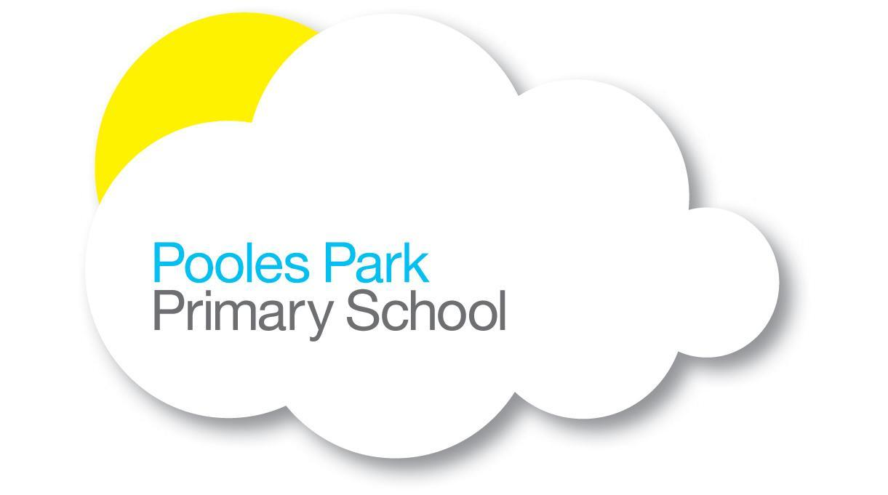

Dear Parent/Carer
NSPCC’s Speak out. Stay safe. programme
We are pleased to inform you that we are participating in the NSPCC’s Speak out. Stay safe. Programme this term. Speak out. Stay safe. is a programme for children aged 5-11 which aims to help children understand abuse in all its forms and to recognise the signs of abuse. Children are taught to speak out if they are worried, either to a safe adult or Childline.
This child friendly programme is aligned with the curriculum and consists of age appropriate virtual assemblies and supporting classroom based activities which we have reviewed, alongside NSPCC volunteer led face to face workshops for children aged 6-7 and 9-11. These will be held in February. The content is delivered in an engaging and interactive way with the help of the NSPCC mascot Buddy. If you would like to know more about the Speak out. Stay safe. programme visit www.nspcc.org.uk/speakout.
Additional NSPCC resources for families to help keep children safe
The NSPCC have shared some important information below on wider NSPCC resources and support to help keep children safe.

Parent/Carer support  Take a look at information, support, advice and activities from NSPCC for parent and carers.  www.nspcc.org.uk/parents | Activities to extend learning at home  Take part in games and activities at home to help children learn about speaking out and staying safe.  www.nspcc.org.uk/activities

Online Safety Hub  For information on a range of different online safety topics including gaming, social media, sharing images, parental controls and more.  www.nspcc.org.uk/onlinesafety | Childline – under 12’s  Childline have an accessible website with advice, support, games and activities. Children can change the language, enlarge text and also listen to the content.  www.childline.org.uk/buddy (5-7)  www.childline.org.uk/kids (7-11)
Talk PANTS with your children
Talk PANTS is a simple conversation to help keep children safe from sexual abuse. From P through to S, each letter of PANTS provides simple but important messages. Download the free resources at www.nspcc.org.uk/pants.

We hope you find this information about the NSPCC and the Speak out. Stay safe. programme helpful. Please do contact the school if you have any further questions.

