A ‘Naturehood for our Neighbourhood’ Project Workshop

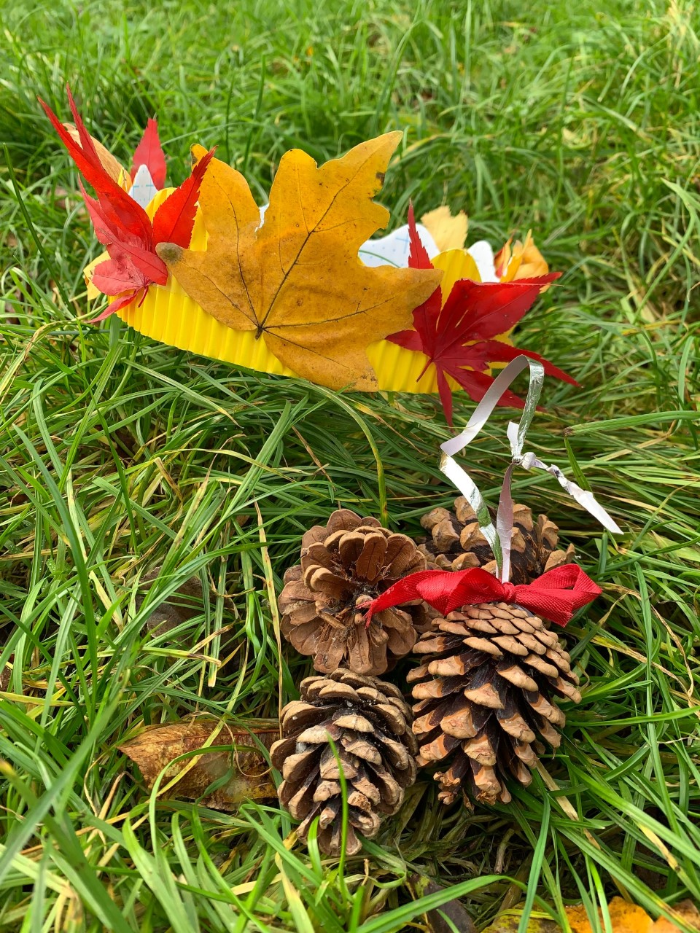
Nature Crafts
For Nursery & Reception’s Parents, Carers and children
on
Thursday 8th December
9:00-10:00am

in
our beautiful Community Garden
and The Cabin

‘Come along and make your very own
Nature crown and Nature decorations’

