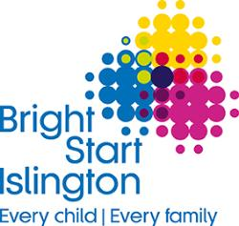

Bright Start Family Support Service
Families with children aged 5-19

Dear Parents & Carers
My name is Teresa Connolly and I am the new Outreach Support Practitioner for Pooles Park Primary School. I am really looking forward to meeting you all soon.
A bit about me:
I have worked in Islington for many years based mostly in the Children’s Centre’s. I have facilitated groups for children and Families especially those who have additional needs and speech and language delay. I have also supported parenting workshops and programmes in partnership with CAHMS.
What I can do:
I will be attending your school on a regular basis to get to know you and provide support on difficulties that you and your family may be facing.
This last year has been particularly hard for us all, so I’m here to support you and your family access the wealth of local services Islington has to offer.
Sometimes I will bring along colleagues from partner agencies to coffee mornings where you can get direct advice on:
Income Maximisation – who can give guidance and support around benefits and tax claims.
IWork – Who have a whole team dedicated to understanding your circumstances and helping you into the best work or training and education opportunities.
Housing – Get help and support with your housing queries. Find out about renting in the private sector and your rights to decent accommodation as a private renter.
Help on your Doorstep – Who help with a wide range of issues including; legal problems, debt advice, employment and learning, housing including disrepair and risk of homelessness.
Shine – can provide advice on saving energy and reducing bills, grants for heating and installation, support with energy and water debt, water and electricity discounts.

