Dear Year 1 and Year 2 children,
We have some exciting news! If you have access to the internet, you will be able to leave messages for your teachers and friends. Ask your parents to follow the instructions below!
We miss you and look forward to seeing you soon.

Shark of the week
Basking Shark
https://www.wildlifetrusts.org/wildlife-explorer/marine/fish-sharks-skates-and-rays/basking-shark
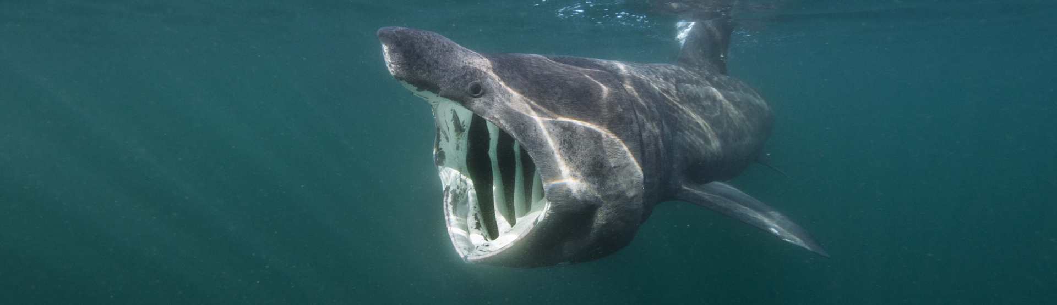

Dear Parents and Carers,
We have some exciting news, see below:
News!
You can now keep in touch with your class on our new blog!
https://pooles-park-primary-school.j2bloggy.com/
1: Log into LGFL using your long LGFL username and your password
2: Click ‘view’
3: Find your Year 2
4: Write a comment to let Mr O, Miss Holmes, Miss Charlton and Mrs Sima know what you have been doing
.
All comments will be checked by Miss John and then approved for everyone to see and reply to. We’d love to know how the children are so please give it a try!
If you don’t have your LGFL password email admin@poolespark.islington.sch.uk
-------------------------------------------------------
We know that some of the children will be using screens more while you are staying safe at home and that is okay! It is important to make sure that:
- They are having healthy screen time - learning or creating things!
- They are mixing in activities that can be done without looking at a screen too - see the section called ‘Non Screen activities you can do at home’.
Stay healthy, happy and safe at home, we can’t wait to see you all again soon!
Miss Charlton, Mr O, Miss Hayden, Miss Baker, Mrs Sima, Miss Holmes and Mrs Edebali.

