Literacy
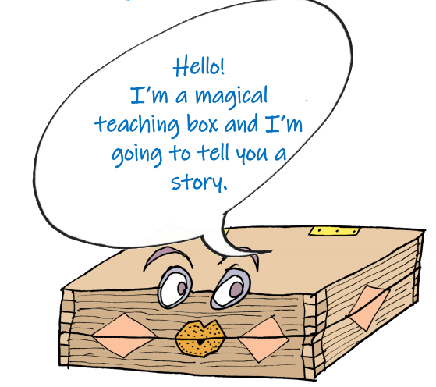
Our topic is ‘Down at the Bottom of the Garden’
Click the link and you will receive a story about a spider called Sidney.
There are lots of activities on the link, if you want to do all of them then that’s great but otherwise do the activities below.

Activity 1: | Activity 2: | Activity 3:
Make a list of all the creatures you might expect to find at the bottom of a garden!  Which ones do you like the most? Are there any which make you feel a bit scared? I hope not!  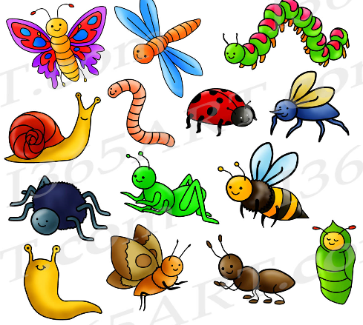 | Come up with an adjective ( a describing word) for each of these creatures  - Worm  - Spider  - Butterfly  - Dragonfly  - Ladybird  - Ant  Can you start your describing word with the same letter as the mini beast you are describing? For example, a wiggly worm. | Let’s use the mini beasts we have described to write a poem.  If you want some inspiration you could read these minibeast poems here  Think of a repeating line that you could use throughout your poem. I am going to use ‘down at the bottom of the garden’.  This is my first verse  A wiggling worm  Some scuttling spiders  A beautiful butterfly  All the different creatures  Down at the bottom of the garden.  Can you see how I’ve included the adjectives I came up with yesterday?  Maybe you’d like to send your poem to a family member that you can’t see at the moment to brighten their day?

Spellings
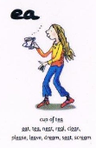
This week we are going to focus on the sound ‘ea’ for ‘cup of tea’
How many words can you think of with the ‘ea’ sound in. Don’t forget it can be confusing because we also have ‘ee- what can you see’. It is easy to confuse them because they sound the same but have different spellings!

Practice spelling these words and then when you can spell them correctly put them into sentences:

sea, tea, neat, treat, beast, please, dream, team, scream, mean

Practise your spellings here:

sea
tea
neat
treat
beast
please
dream
team
scream
mean

Use these words to complete the sentences

Miss Haydon loves a cup of ___________

If I see a spider I might ___________

Last night I had a very strange __________

I don’t like it when my brother is __________

Phonics and reading

Reading, reading, reading - it is the most important skill you will ever learn!
As Dr Seuss says

I have created an Oxford Owl login for you. You should be able to access this on your phone.
Go to this website: https://home.oxfordowl.co.uk/
Your username is ppvictoria and your login is 1234

Try to read at least one book per day

Phonics Play
www.phonicsplay.co.uk Username: march20 Password: home

Phonics
Blend the sounds in these words
Which ones are real words and which ones are not real?

Word | Real | Not real
glurb
slice
blumb
race
tream
glint
show
flicious
delicious

Maths
Please use the White Rose Maths resources where you will find daily activities and videos to support. The learning is organised in weeks, we will be in week 2 next week.
https://whiterosemaths.com/homelearning/year-1/

You can access these on your phone too.

In Year 1, the expectation is that children can write the digits 0- 20 correctly and spell them in words. Practice these along with your other spellings.

One |  | Eleven
Two |  | Twelve
Three |  | Thirteen
Four |  | Fourteen
Five |  | Fifteen
Six |  | Sixteen
Seven |  | Seventeen
Eight |  | Eighteen
Nine |  | Nineteen
Ten |  | Twenty

Science
We are starting a new Science topic all about animals, including humans. Use this BBC Bitesize clip to find out more about minibeasts.
https://www.bbc.co.uk/bitesize/topics/z6882hv/articles
/z9fkwmn

Can you name all of these creatures?

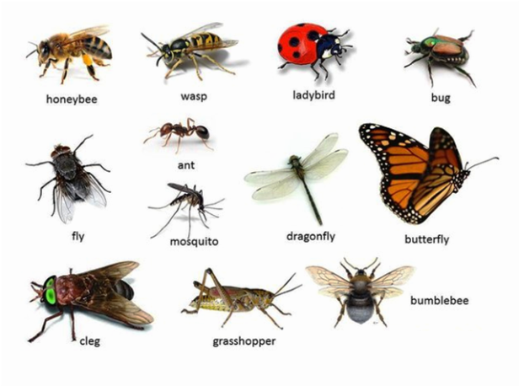

Topic

On your daily exercise, have a look to see what minibeasts and birds you can see. Can you make a tally chart of how many you find?

Last half term we started learning about the different continents around the world. This half term we will look at the different minibeasts which are native to each continent.

Practice your continents song on Youtube here: https://www.youtube.com/watch?v=K6DSMZ8b3LE
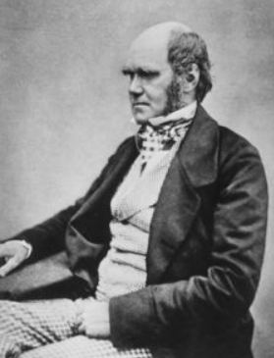

This is Charles Darwin.

He did lots of research into how plants and animals changed and adapted overtime to suit the environments they live in.

Use this link to find out more about what he did.
https://kids.kiddle.co/Charles_Darwin

Music
Use these resources from the Royal Albert Hall and meet the orchestra with Albert’s band.
https://www.royalalberthall.com/about-the-hall/news/2020/april/meet-the-orchestra-with-alberts-band?utm_source=wordfly&utm_medium=email&utm_campaign=children-and-families&utm_term=families-royal-albert-home-4&utm_content=version_A&emailsource=53974#horn
Activities for the week
Alphabet Scavenger Hunt
Can you explore your home to find something for each letter? Play with someone else in your household and see who gets the most objects from the whole alphabet!
Five Senses Nature Scavenger Hunt
Use all your senses and explore outside (either on a walk or in a garden) to find as many of the challenges as you can.

