Dear Key Stage Two children,

We hope that you are feeling well and are enjoying your time with your family and we also hope that are showing that you are showing and sharing our Pooles Park values at home:

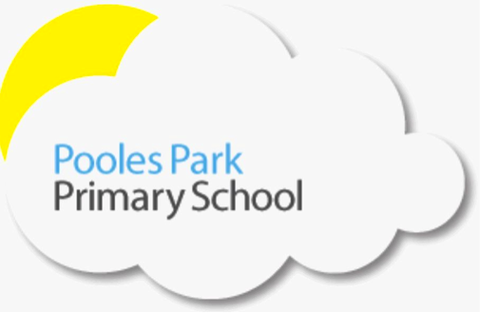We are responsible We are respectful We are ready

We are very proud of you all for being so mature and resilient during this challenging time. The Key Stage 2 adults have been working together to provide you with resources to keep you busy and to exercise your brains over this time. We all miss seeing your faces every day but we are glad that you are all keeping safe.

Dear Parents and Carers,

Thank you for the support you have given the children and members of staff at this time. Your child’s class teacher will be calling you to check in and see if there’s anything we can do to support you even further.

Class teachers will be creating weekly home learning resources that will be shared on our school website with a variety of different activities linked to our Summer curriculum. We appreciate that it is a challenging time so please only do what you can; the resources will provide you with options so choose an activity/amount that suits your circumstances. The most important thing is that children are as healthy and happy as possible.

In addition to the resources prepared by class teachers, the government has unveiled a new package to support home learning under the name of the Oak National Academy from April 20th. It will include 180 video lessons each week, supporting children from Reception to Year 10. Find out more here: https://www.thenational.academy/ and here: https://www.gov.uk/government/news/new-major-package-to-support-online-learning. The BBC is also delivering learning resources across BBC iPlayer, Red Button, Bitesize, Radio 4 and BBC sounds from April 20th. Every day, 6 Bitesize programmes will air on BBC iPlayer. Find out more here: https://www.bbc.co.uk/mediacentre/latestnews/2020/coronavirus-education.

We look forward to seeing you all as soon as possible and if you need to get in touch with any member of staff please email our admin address: admin@poolespark.islington.sch.uk

Miss John, Miss Murphy, Miss Bye, Miss Robinson, Miss Rampasad, Mr Craig, Miss Naz, Miss Mehmeti, Miss Chicken, Miss Timlin, Miss Paxman, Miss Baker and Miss Moir.

Key Stage 2 Adults

