Dear Year 1 and Year 2 children,
It has been so lovely to speak to some of you this week on the phone. We will carry on calling over the next few weeks. We hope that you are still feeling healthy and happy!

We hope that you have been able to complete some of the learning activities we have set and even explored important learning of your own by making forts, helping with the cooking and playing with your family.

We miss you and look forward to seeing you soon.

Shark of the week
Tasseled Wobbegong (Miss Charlton’s favourite!) Find out about them here:
https://www.bbc.co.uk/programmes/articles/1Nmj6hynkDMfryQkVZJkmgy/tasselled-wobbegong
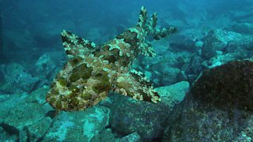

Dear Parents and Carers,
We have enjoyed speaking to lots of you this week and will continue to call over the next few weeks if you haven’t heard from us yet!

In addition to the learning packs that we have created, we can recommend the following sites for education games and activities to support your child’s learning:
- BBC Bitesize provides daily lessons in all subjects, this can be accessed on the website https://www.bbc.co.uk/bitesize/dailylessons or through pressing the red button on your TV while on a BBC channel.

- LGFL has a range of online resources across all subjects. Children have an LGFL login card to access these resources.

Stay healthy, happy and safe at home, we can’t wait to see you all again soon!
Miss Charlton, Mr O, Miss Hayden, Miss Baker, Mrs Sima, Miss Holmes and Mrs Edebali.

