Literacy
Last half term, we were learning about Jeremy Strong and how he makes his writing funny. Have you got any of his books at home?

Take a look here: https://www.jeremystrong.co.uk/krazy-klub-sneak-peeks/
Activity 1: | Activity 2: | Activity 3:
First, think about fairytales - what does the genre typically contain?  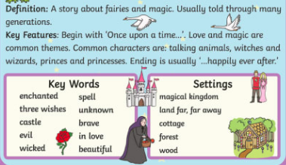  Jeremy Strong turns these upside down and other authors have been inspired by this idea too:  Roald Dahl’s Revolting Rhymes, also takes the three little pigs and makes a new version with a funny twist:  https://www.youtube.com/watch?v=F5DS2DnsJ04  On paper make some notes:  1. What do you like about it?  2. What do you dislike about it?  3. Does it remind you of anything you know about already - stories, films, real life? Explain why.  4. What questions about this Revolting Rhyme would you want to ask Roald Dahl if you could? | Let’s plan our own modern version of the The Three Little Pigs  You can put a twist on the typical fairytale in lots of ways:  - Unexpected setting.  - Changes to characters:  - evil -> good  - good -> evil  - Funny names.  - Modern language  - A new problem or different events (a little bit silly).  - A strange solution to the problem.  - A different point of view - like from the witch, instead of the princess.  - Humour!  https://www.youtube.com/watch?v=rZpYMLp1LdQ Here the pig has been made the baddy!  How will you retell the story of the three little pigs?  Grab some toys to act as props (or use your character puppets from art if you’ve completed that challenge) or scribble on some note paper your ideas.  Now neatly draw a story map showing the key events. | https://www.youtube.com/watch?v=rZpYMLp1LdQ  Rewatch the video. What does the author do well? What punctuation do you notice? What other skills does the author show?  Aim for a paragraph for each section:  opening, build up, climax, resolution, ending.  - Paragraphs (for new events / settings / characters)  - Lots of setting descriptions.  - Different sentence openers.  Before long, A little later, Once the sunset, Scared, Curious, Inside the house,  - Speech with correct punctuation  “Huff!” blew the wolf.
NS: After you have written your sentences and story, read them again. Edit and improve your writing, like we do at school!
- Additions (adding in missing words or phrases)
- Revisions ( improving sentences or word choices )
- Corrections (correcting wrong spellings)
Now read your story to someone in your family!
Challenge: illustrate your story to create a picture book for younger children

Want some more writing inspiration?

Why not write a whole series of twisted fairytales? Perhaps - little red riding hood lured the wolf to her grandmothers before killing him for his fur?

The National Literacy Trust has made a family zone with links to lots of exciting sites focused on writing and reading. One of our favourites is Michael Rosen reading his poetry and stories because he reads with such a range of expression, making funny voices and silly faces!
https://literacytrust.org.uk/family-zone/5-8/

Spelling
Activity 1:
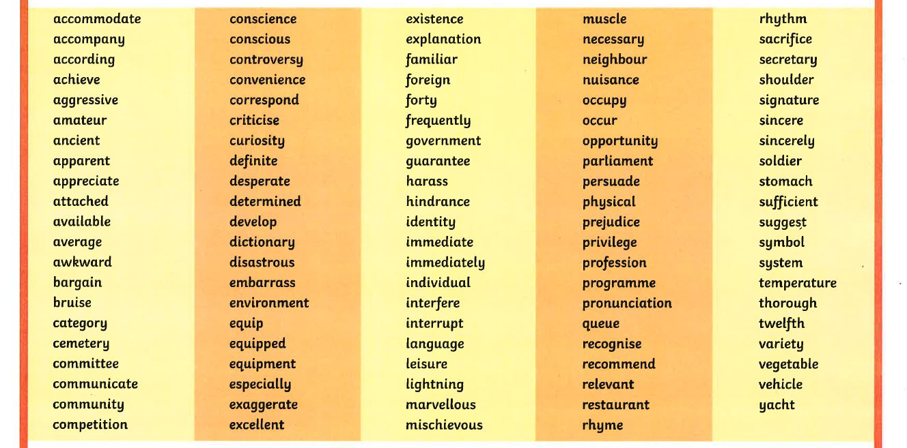
Choose ten spellings from the list below. They all follow unusual patterns so have to be learnt especially.

- Look up their meaning. You can use an online dictionary. If you can, listen to how they sound when they are read out loud by clicking on the speaker button.
- Can you think of three synonyms for that word, just like if you were a thesaurus?
- Use your neatest handwriting to write them in sentences.

At the end of the week you can give yourself a spelling test of your ten words!
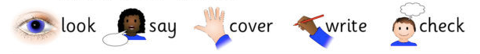
Made a mistake? Notice where you went wrong, and re-learn it!
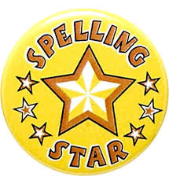
Activity 2:
Want to be a spelling superstar when we get back? Then use this website https://spellingframe.co.uk/spelling-rule/5/Year-5-and-6 to practise some of our regular spelling patterns.

Spelling Rule 37 - Endings which sound like /shus/ spelt –cious or –tious.

The shus sound is often found in adjectives and can be spelt in two different ways: cious or tious. For example: delicious, precious, suspicious, fictitious, infectious, nutritious.

Reading

Reading, reading, reading - it is the most important skill you will ever learn! Keep up with your daily reading, whether it is a comic, facts on a website, non-fiction or fiction books or a letter from a friend.

Guided reading:
1. Go to www.readworks.org/student
2. Enter the class code ZXWXUN
3. Your default password is 1234
Online book corner:
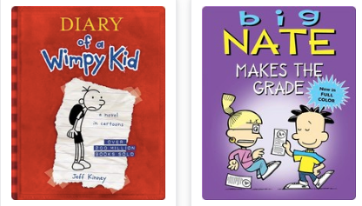
You can also access books on Epic - either on the web or by downloading their free app.
- Go to the website or the app store: www.getepic.com/students
- Log in with the class code mcs7564
- Select your name from the list.
You can read books on your device like Diary of Wimpy Kid or Big Nate.

Story time
Sometimes we just want to listen to a story. This website is out of this world! Astronauts on the International Space Station read a wide range of stories. https://storytimefromspace.com/library/

Maths

Please use the White Rose Maths resources where you will find daily activities and videos to support. The learning is organised in weeks and there is a lesson for each day

Maths lesson:
Please start with week 1: https://whiterosemaths.com/homelearning/year-5/

Daily Practise:
To keep all your skills fresh and so you don’t forget all your wonderful learning, you’ll need to keep revisiting things we’ve already learnt, just like we do at school with a daily practise! You could use Mathletics, or follow this link and choose a skill. There are videos to remind you what to do. Use the answers to check your work!
https://myminimaths.co.uk/year-5-mini-maths/

Timestables:
In Year 5, the expectation is that children know all the times tables in order, muddled and speedily. We also have to know the linked division facts. Make a poster of fact families for a multiplication and division you still find tricky.
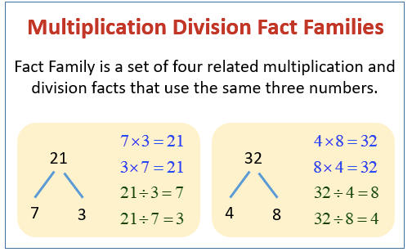
Use your times tables books to practise, Mathletics or visit https://www.timestables.co.uk/.

Science

Our topic is the properties of materials (the stuff an object is made out of). Designers, scientists, builders, artists - even you in your home - will make decisions about what to use for different jobs based on the properties of materials.

Find out more about materials here: https://www.dkfindout.com/uk/science/materials/

Sometimes it will be important if it’s absorbent (like a sponge to soak up spilt water), other times that it’s a thermal insulator (like your duvet keeping you lovely and warm in bed!).

- Materials at home

write down 10 different items. Record what materials the items are made of. Write down all the properties the materials have that you can think (use the word bank at the end of the document to make sure you’re using scientific vocabulary).
- Underline the most important key properties for the function (the job) of the item.
- Explain you’re thinking.
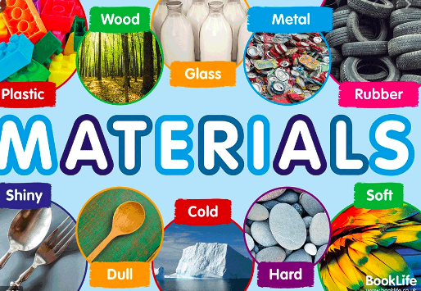
- Suggest an unhelpful material
Item - a cup
Material - glass
Properties - transparent, waterproof, rigid, thermal conductor, smooth, hard, brittle.
Explain - It has to be waterproof so that liquid does not leak out, and rigid so that it holds its shape when you pour water in and doesn’t spill.
Unhelpful material - If you made a cup out of fabric, it would be absorbent and not water proof, when you tried to have a drink it would have leaked all your liquid onto a surface.

- Be amazed by some of the amazing material inventions scientists have made!

Anti-bacterial coating based on a shark’s skin, a material for space ships, plastic alternatives made from mushrooms and even bananas, and a material that acts like an invisibility cloak!

- https://thekidshouldseethis.com/post/mimicking-shark-skin-to-combat-superbugs-bacteria-biomimicry
- https://thekidshouldseethis.com/post/quantum-stealth-invisibility-cloak
- https://thekidshouldseethis.com/post/aerogels-science
- https://thekidshouldseethis.com/post/mycelium-packaging
- https://thekidshouldseethis.com/post/google-science-fair-meet-elif-bilgin

- Be an inventor!

What material would you invent? What would you use if for? Draw a comic strip or poster showing your material in use, and explain it’s wonderful properties!

Could you get inspiration from the natural world too?

- Be an architect!

The Three Little Pigs are fed up with their houses being knocked down. Can you design a new house for them? What materials would you use to wolf-proof their house? Draw and label your design.

Can you improve on this design?
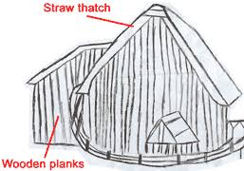
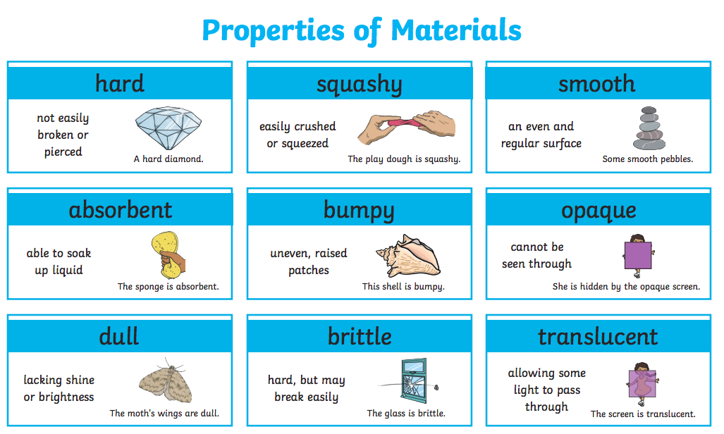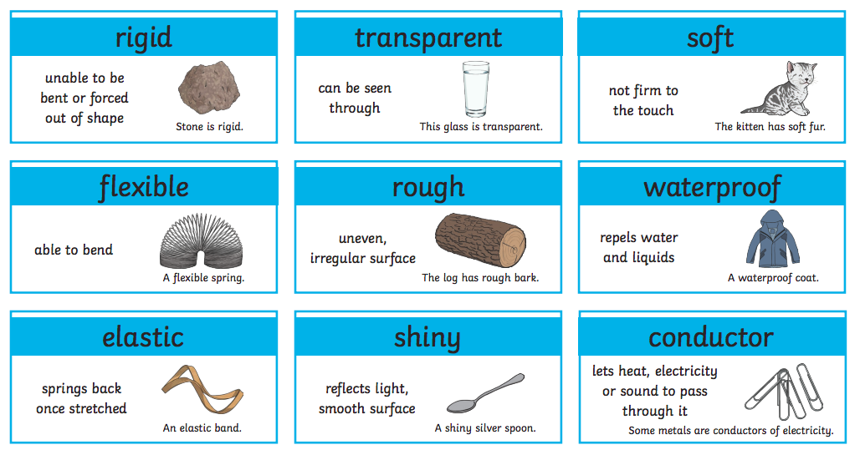
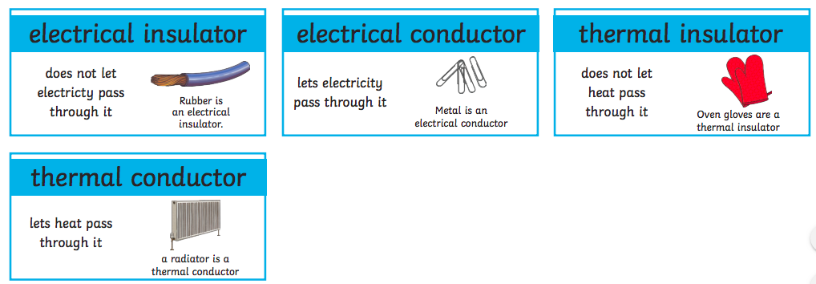

Topic

We are going to research some real life inventors of materials. Can you find out what these people invented?
Use a safe search engine to help:
https://www.alarms.org/kidrex/
https://www.researchify.co.uk/.

Maria Telkes

Stephanie Kwolek
- Joseph Aspidin
- Wallace Carothers
- Alexander Parks
- John Boyd Dunlop

Show what you have learnt about them by making a fact file, a poster, leaflet or a quiz about them both. If you have an ipad, you could even write a book like we did at the discovery store!

Art
Make a puppet from a chatterbox!
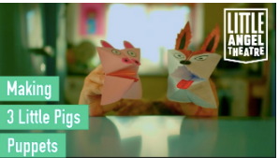

In this video they show you how to make a wolf and three little pigs. Can you adapt the design to make puppets from other fairy tales? https://www.youtube.com/watch?v=5UOx-k2gZ-Q

How about having a go at making some puppets to retell another fairytale in the style of Jeremy Strong?

How might your characters act in unexpected ways and challenge stereotypes from fairytales?
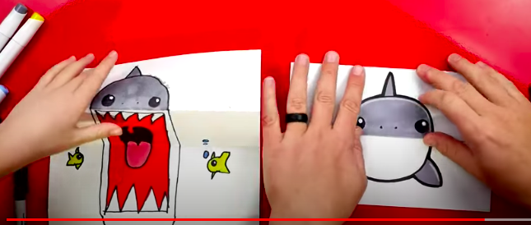
If you want to introduce a surprising character, have a go at this folded shark! Go to youtube Kids Art Hub https://www.youtube.com/watch?v=wy2-3BxdtYY

