Literacy
Last half term, we were learning about fairy tale writing. Let’s use our creativity to write about this story: The Little Shoemaker
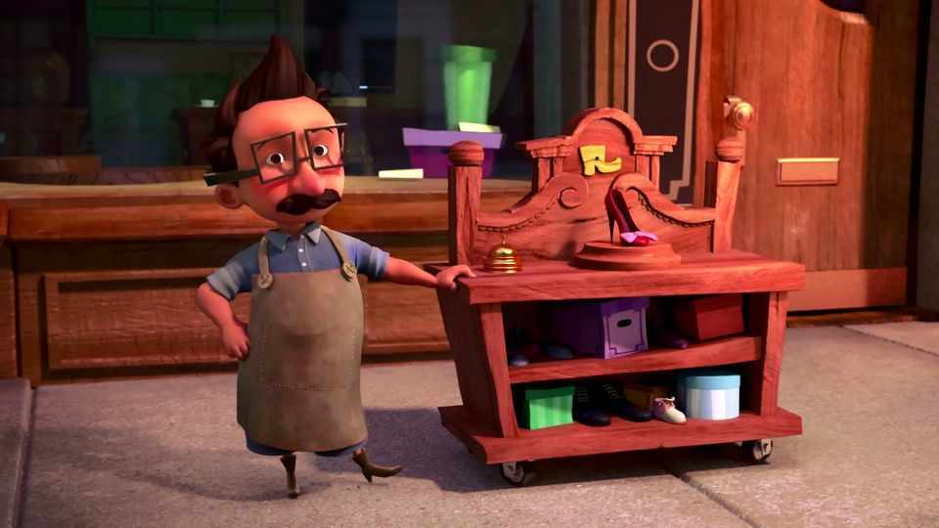

Activity 1: | Activity 2: | Activity 3:
First, let’s use our inference (good guessing) skills. Look at the image and spend 2 minutes writing what you can see. Then spend 2 minutes writing what the image makes you think about. Finally spend 2 minutes writing what the picture makes you wonder. If you do this activity with your family, I wonder if they had the same thoughts and wonderings as you! | Extend this sentence to add more detail.  There was a shoemaker called Brian.  - First add a fairytale sentence starter.  - Then add 2 adjectives to describe the shoemaker.  - Next add ‘who’ and describe where Brian lived.  Challenge your family to do the same, how many different ways can you describe Brian? How many different ways can you describe where he lived? | Watch this video https://www.literacyshed.com/littleshoemaker.html  - Draw a story map to tell what happend  - Retell the story with actions using:  A mouse’s squeaky voice A scared voice  A giant’s booming voice  ----------------------------------------  Write the story of the shoe maker. Can you tell it like a fairy tale?  Fairytale language:  Once upon a time town folk enchanted  Use adjectives to describe nouns (people, places or things):  kind poor lonely glamourous sly cunning loud shiny magical  Use adverbs to describe verbs (actions or states):  unbelievably surprisingly amazingly oddly curiously quietly loudly too
NS: After you have written your sentences and story, read them again. Edit and improve your writing, like we do at school!
- Additions (adding in missing words or phrases)
- Revisions ( improving sentences or word choices )
- Corrections (correcting wrong spellings)

Spellings
Practise spellings from list 1. Use your neatest handwriting to write them in sentences.
https://content.twinkl.co.uk/resource/6f/38/T-HE-101-Home-Educators-Spelling-Lists-Year-2-Summer-1.pdf?__token__=exp=1587203782~acl=%2Fresource%2F6f%2F38%2FT-HE-101-Home-Educators-Spelling-Lists-Year-2-Summer-1.pdf%2A~hmac=aff4c9ba847f4de0642e48ed80968e9bfbdbeff3dda43b067b21c88425111bea

Phonics and reading
Reading, reading, reading - it is the most important skill you will ever learn! Keep up with your daily reading, whether it is a comic, facts on a website, non-fiction or fiction books or a letter from a friend.
Phonics Play
This site usually has some free games, but they have made it completely free.
www.phonicsplay.co.uk Username: march20 Password: home
Story time from space
This website is out of this world! Astronauts on the International Space Station read a wide range of stories. https://storytimefromspace.com/library/

Writing
The National Literacy Trust has made a family zone with links to lots of exciting sites focused on writing and reading. One of Miss Charlton’s favourites is Michael Rosen reading his poetry and stories because he reads with such a range of expression, making funny voices and silly faces!
https://literacytrust.org.uk/family-zone/5-8/

Flash academy offers lots of different videos covering different subjects, but Miss Charlton and Mr O really enjoy the grammar videos to challenge us and make our writing even better!
https://flashacademy.com/grammvideos

Maths
Please use the White Rose Maths resources where you will find daily activities and videos to support. The learning is organised in weeks. Please start with week 1: https://whiterosemaths.com/homelearning/year-2/

In Year 2, the expectation is that children know the 2,5,10 times tables in order, muddled and speedily by the end of the year. If you need an extra challenge, the next step is 3 times tables.
https://www.timestables.co.uk/

Science
Activity 1 - Plants
- Collect pieces of fruit. What do they look like? What do they smell like? What do they feel like? What do they taste like?
- Draw a table or a mind map to record your answers. I wonder if your answers are the same as everybody in your family.
- Do you know what they look like inside? Open them up and draw scientific studies labelling the different parts.

NS: Fruits have seeds or pips inside them. If you can, plant the seed or pip. Where would be the best place to put it? What happens to it over time?

Activity 2 - Materials
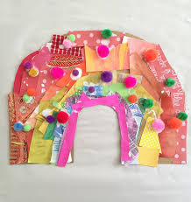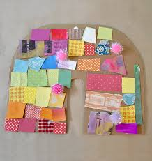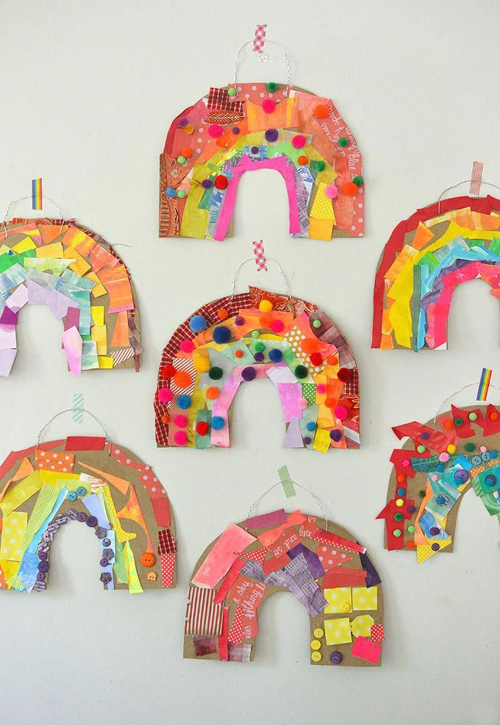
Material rainbow
Gather different coloured materials together. Can you collect materials that are every colour of the rainbow?
- Choose a property (rigid, flexible, soft, smooth, rough, opaque, transparent) and group the materials in different ways.
- Ask an adult which materials you can use to create a textured rainbow collage to display in your window.

Activity 3 - Materials
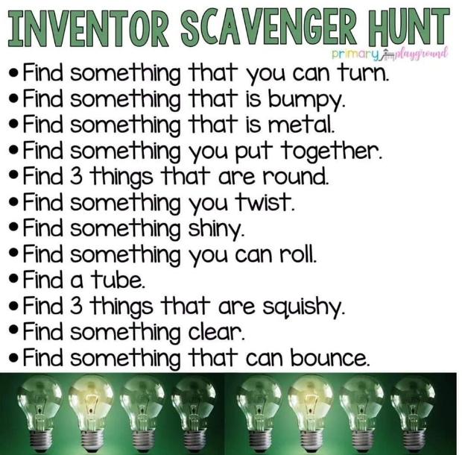

Topic - We Can Be Heroes!
Florence Nightingale and Mary Seacole were real life heroes who made big changes in our world. Use a safe search engine to find out about their lives.
https://www.alarms.org/kidrex/
https://www.researchify.co.uk/.
Show what you have learnt about them by making a fact file, a poster or a quiz about the person who you think is most interesting.

Craft
There are lots of things to watch, do and make on the Little Angel Theatre website. Lots of them are linked with our last topic, which was Fairytales.
https://littleangeltheatre.com/schools-and-community/at-home-resources/?utm_campaign=1723741_Online%20activities%20-%20for%2011x11%20schools&utm_medium=email&utm_source=littleangeltheatre&dm_i=2U8A,10Y1P,7HH9YG,3WJ3O,1

