Literacy
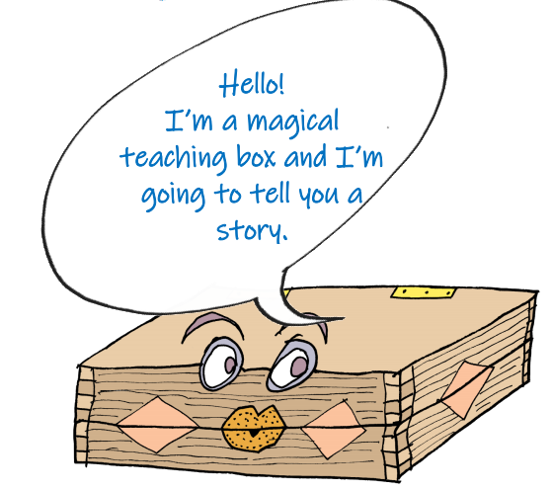
Our new topic is, ‘We can be heroes!’. This week, click the link and you will read an ancient Greek myth. Greek myths were often about heroic (brave) adventurers! This week, we are going to focus on the story of Pandora’s box. We will focus on the Magic Box poem next week.
https://www.talk4writing.co.uk/wp-content/uploads/2020/04/Y2-Unit.pdf
Activity 1: | Activity 2: | Activity 3:
Read the story of Pandora’s box (pages 4, 5, 6, 7, 8) and complete all of the drawing activities’. 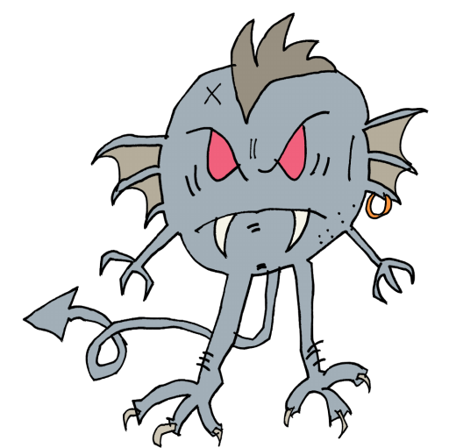  When you have read the story, write about what you enjoyed or didn’t enjoy about it. Talk about your ideas with someone in your family. | Read the story again, remember to use the punctuation to help read with expression.  Answer these questions using full sentences:  ▪ How did Pandora change the world forever?  ▪ When is the story set?  ▪ Who was in charge of the Ancient Greeks?  ▪ What kind of character was Pandora?  ▪ Who was Prometheus?  ▪ What is the evil that comes out of the box compared to?  ▪ Why do you think hope is a butterfly in the story?  ▪ Do you like the ending of the story? Explain your answer. | Match the words from the story to their meanings (page 11), then read the sentences on page 12. Create your own sentences using the words.  For an extra challenge, create a story using as many of the words as you can.
If you want to, you can complete the activities on pages 10 and 13 too!

Spellings
Practise spellings from the words below and you put them into sentences.
braver closest cutest fastest harder largest quicker nicest slowest softer

Phonics and reading
Oxford Owl
There are lots of books online from different genres, and spelling activities. Just click on ‘My class login’ at the top of the page. https://www.oxfordowl.co.uk/
Covent Garden class: Username: coventgarden1 Password: park
Piccadilly Circus class: Username: PiccadillyC1 Password: Park

Story time from space
Tim Peake is Miss Charlton’s favourite astronaut. Watch him read The Incredible Intergalactic Journey Home! https://storytimefromspace.com/library/

If you are in Miss Charlton’s reading group, or if you would like an extra reading challenge, complete the lessons about ‘The Firemaker’s Daughter’ here: https://www.thenational.academy/year-2/english/the-firework-makers-daughter-to-retrieve-information-year-2-wk1-1/
https://www.thenational.academy/year-2/english/the-firework-makers-daughter-to-find-the-meaning-of-words-year-2-wk1-2/

Writing
Use your punctuation, spelling and prefix/suffix skills to help the STS (Small Town Superheroes)! https://www.bbc.co.uk/games/embed/small-town-superheroes?exitGameUrl=http%3A%2F%2Fbbc.co.uk%2Fbitesize%2Farticles%2Fzncgvk7

Maths
Please use the White Rose Maths resources where you will find daily activities and videos to support. The learning is organised in weeks, we are in week 2. https://whiterosemaths.com/homelearning/year-2/

In Year 2, the expectation is that children know the 2,5,10 times tables in order, muddled and speedily by the end of the year. If you need an extra challenge, the next step is 3 times tables.
https://www.timestables.co.uk/

Science
We are starting a new Science topic all about animal’s habitats (where they live). Click on the link below. Complete the ‘Food Chains’ activities: watch the video and complete the quiz. https://www.bbc.co.uk/bitesize/subjects/z6svr82.
Then draw a poster showing 3 different food chains, like this:
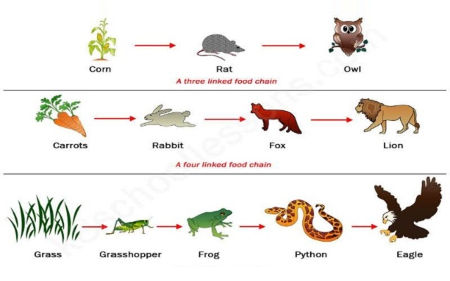
Topic
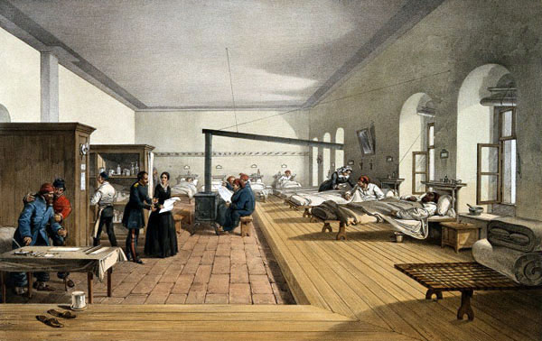
Above is a picture of one of the hospitals Florence Nightingale worked in. This was called the Scutari Hospital.
Discuss or write answers to these questions.
- What jobs are the nurses doing?
- What other jobs can you see being done?
- Who do you think the men are in this picture?
- Does this look like a comfortable place to stay in? Why?
- What do you think are the differences between this hospital and a hospital today?
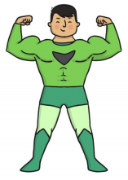
Design and Technology- Healthy Eating
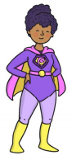
- Your superhero needs help! After a long day of saving the world, the superheroes need a healthy snack to regain their strength and power. Taste and describe some fruits and vegetables and decide which ones to include in a smoothie or fruit salad. What is the name of your smoothie or salad?
2. Design the packaging.

Music
Here is an introduction to an orchestra. This week, watch the video about percussion and discuss the questions with a family member. Have a go at making your own percussion instrument. Can you compose a song? Perhaps a rap?
https://www.royalalberthall.com/about-the-hall/news/2020/april/meet-the-orchestra-with-alberts-band?utm_source=wordfly&utm_medium=email&utm_campaign=children-and-families&utm_term=families-royal-albert-home-4&utm_content=version_A&emailsource=53974#horn

