EYFS Home Learning

Hello everyone, welcome to week two of the summer half term. As we have said before, the activities we provide are suggestions to help you keep some routine to the day and for your children to have something to focus on. It isn’t always possible to get everything done and we do not expect you to so choose what you like!

If you haven’t already heard from us, we will be contacting you this week, to say hello and to see how you and the children are all getting on, so expect a phone call!

Please email us if you cannot access Tapestry on admin@poolespark.islington.sch.uk so we can organise your login. We have caterpillars and are uploading video clips so you can see their transformation.

Try to keep the children active with the suggestions previously made, it is important to exercise everyday! Joe Wicks, Andy’s Wild Workouts on Cbeebies Cosmic Kids Yoga and The Friends Flow!💞- Hey Duggee Yoga Part 1 - Hey Duggee are all options.

Your children can continue to learn phonics via RWI Ruth Miskin’s website Home reading
There are phonics lessons each day beginning at 9.30 which will be available for 24hrs. There is a schedule online showing which sounds will be taught each day
Ruth Miskin Training

Continue to read regularly with your child and encourage them to read some words or sentences even if just for two minutes a day. Practise makes progress!
Oxford Owl for Home: help your child learn at home
There are other books available for children who are ready to move on Free eBook library
If this is not possible, you can read any stories together and let children jump in and read words that are easier, and talk about what is happening in the story, the characters, what might happen next and how the characters are feeling.

Alphablocks is a Cbeebies children’s program which can support ‘Fred talk’ and blending of CVC words and beyond. You can watch episodes on Youtube (with an adult present) as well as downloading the free app: ‘meet the alphablocks’.

Your children love numberblocks! NCETM (national centre for excellence in the teaching of maths) also endorses ‘Numberblocks’ and you can find the episodes on CBeebies and youtube (always with an adult present). Numberblocks - CBeebies
Find the songs on here for your children to learn! Singing about ‘one’ may not seem tricky, but understanding ‘one’ is very important when you get to double and treble figures!!

Keep enjoying mathseeds and use your LGFL login details to use busythings for some active screen time.

Monday 20th April

Activity 1: | Activity 2: | Activity 3:
Read Lost and Found by Oliver Jeffers or watch it being read on youtube Lost and Found By Oliver Jeffers  Look at a globe or a map (there is one at the end of this document). Show your child where the UK is on the map and then where the penguin has come from. With your fingers, trace the journey from here, the UK, to there, Antarctica. Look at all the water between the UK and Antarctica. How could we get to Antarctica? There is a map at the end of this document for you.  How do we think the penguin got to the boy's home? You could play the “may be game”. Take turns making different suggestions:  Adult: MAYBE he was kidnapped Child: MAYBE – your child’s idea Adult: MAYBE he chased a fish all the way here!  Child: MAYBE – your child’s idea (and so on)  You could play this with other members of your family, or if you are on video chat with other family members, perhaps they could play. | Log into your free Oxford Owl for Home website and the children can practise writing their numbers with these familiar songs:  Maths skills ages 4-5  Scroll down til you see  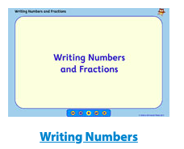  And click on writing numbers.  The children can use pens, pencils, chalk or just use their fingers in the air! | Independent activity!  This story has a penguin in it and penguin begins with the ‘p’ sound. Show your adult how to sound out ‘p’ without UH at the end - push the air through your mouth!  How many things can you find that begin with ‘p’.
Open this book Nog in the fog to read or be read to each day. Today have a look at Ditty 1 together.

Ruth Miskin Training 9.30 Phonics, then practise writing the sound correctly.

Tuesday 21st April

Activity 1: | Activity 2: | Activity 3:
Do you know where penguins come from? What do you know about Penguins? There are different kinds of penguins. Let’s find out a little bit more.  All About the Adélie Penguin | Continent 7: Antarctica  Watch the clip. Try moving like a penguin and talk about how your body is different to the penguin’s body. Can you jump like the penguin? Waddle like the penguin? Slide like the penguin?  Make a list of what you can find in the sea! Say the words slowly and stretch out the sounds so you can hear as many as possible. Use the sound chart at the end of the document to help you. Tell the sounds to a family member for them to write down or write them yourself.  fish (might need to be shown ‘sh’ if writing)  penguins (pengwins/pgns)  ships | Do you have any board games that use dice? Perhaps snakes and ladders? Play a board game, practice recognising the dots on the dice. Learn about taking turns and waiting for your go. Move your counter the correct number of spaces.  If you have one die (dice) then you could play ‘Don’t roll a number six’. It is simple but tricky at the same time:  Take turns rolling the die. Each time add on the amount you roll. See how high your number can go. BUT! If you roll a number six you go all the way back to zero.  E.g. rolls 3  Next person rolls 2  3 and 2 is 5.  Next person rolls 4  5 and 4 makes 9.  Next person rolls a 6 oh no! All the way back to zero and start again. Can you beat 9? | 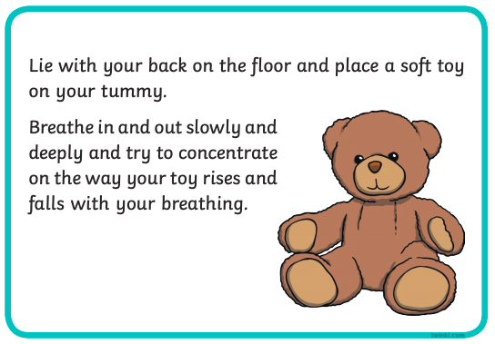  Take a moment for yourself. This is a lovely activity to do to enjoy a quiet moment. It will help you to calm down if you are feeling upset. Do this daily, or when you need to.
Nog in the fog Read Ditty 2 together and talk about the questions at the end of the story.

Ruth Miskin Training 9.30 Phonics, then practise writing the sound correctly.

Wednesday 22nd April

Activity 1: | Activity 2: | Activity 3:
In the story, (you could watch it or read it again), the penguin and the boy test the boat for size and strength before they set sail. The boat floats! Do you know why some things float and some things sink? You could watch Maddie explain (it’s a little bit quick so someone older might need to help you understand her and pause the song). CBeebies | Do You Know Songs | Sinking and Floating  This clip is more in depth Why Do Ships Float?  Can you find different objects around your home or outside on your walk to test to see if they sink or float? Fill up the sink or a bucket with water. Make a prediction before you test it:  I think the stone will sink because… You could try a piece of fruit, a piece of lego, a stone, a leaf etc. | Go on a scavenger hunt for your outside time. Can you find any of the following things:  A flower  A twig  A leaf  An ant  A spider’s web  A shadow  Someone’s picture of a rainbow  A bird’s nest (ooh that’s hard)  A purple car (also a tricky one)  A red door  How things were there in the list?  How many things did you find?  How many things couldn’t you find?  Well done! | Can you use some toys to make your own classroom? Perhaps get a couple of your teddies or play people and read them one of your favourite stories. You can do this without a grown up.
Nog in the fog Read Ditty 3 together and talk about the questions at the end of the story.

Ruth Miskin Training 9.30 Phonics, then practise writing the sound correctly.

Thursday 23rd April

Activity 1: | Activity 2: | Activity 3:
When you go on a long journey, you don’t see the people you have left behind for a little while. At the moment we can’t see lots of our friends and family but we can stay in touch. Can you do a drawing for someone? You could also write them a message. Perhaps you can post it during your outside time, or you could take a photo and send it to them by email? | Here’s a little experiment. You need an ice cube, salt and a little food colouring  Science Fun: Ice Melting With Salt | Watch an episode of numberblocks. Listen carefully to what is being taught. Tell someone in your family what happened in the episode you watched. What was it all about?  Numberblocks - Series 2: Numberblock Castle
Nog in the fog Read Ditty 4 together and talk about the questions at the end of the story.

Ruth Miskin Training 9.30 Phonics, then practise writing the sound correctly.

Don’t forget to do some daily exercise!

Check out Tapestry! Look at our caterpillars. Perhaps you can load up something onto tapestry that you have done to show us. We would love to hear from you.
https://tapestryjournal.com/
Email us if you have a problem logging on
admin@poolespark.islington.sch.uk

Friday 24th April

Activity 1: | Activity 2: | Activity 3:
It’s very cold in the Antarctic. In other places it’s very warm. Which kinds of animals live in hot climates? Try this African Animals Dance:  https://www.youtube.com/watch?v=c7l5oUWE73g&t=67s | Have you been doing this?  I do it everyday when I get up! It helps me to feel better about everything that is going on. Perhaps you are grateful because the sun came out. Maybe you are grateful because you have your favourite toy to hold. You can be grateful for having clean water to drink or having running water for your bath or shower!  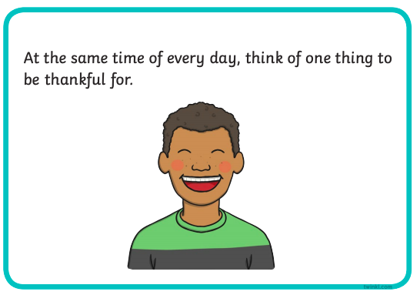 | Do some cooking together! You can measure out ingredients together or you can look at the science of how food changes as you cook it.  For example if you are cooking rice, do you measure one cup of rice to two cups of water?Do you add anything to the rice to give it flavour or colour? I add turmeric and some spices to make tasty yellow rice!  What happens when you cook eggs? Can they go back to their original form?
Ruth Miskin Training 9.30 Phonics, then practise writing the sound correctly.

The children enjoy singing in Spanish. This is a game we play to see how quickly we can say ‘chocolate’ whilst doing different hand actions. Give it a go! (Always have someone present when using youtube) CantaJuego - Chocolate (Version Mexico)

