EYFS Home Learning

Welcome to the new term. A strange start to the term for us all. We hope you are all well and will enjoy these activities. Please remember that whilst it would be great to be able to do all these activities, it isn’t always possible, so please take these as suggestions and do not worry if you can’t get them done. Whilst these activities are aimed towards reception, nursery can do many of them too!

We will be contacting you soon, to say hello and to see how you and the children are all getting on, so expect a phone call!

It would be lovely to see what you are doing at home. Please take photos and load them up onto Tapestry. It is a good way of being able to stay in touch and we have already put up a couple of posts. Thank you to those of you who have been using Tapestry, it is lovely for us as well. If you are having problems logging in, please email us and we will resend you a link: admin@poolespark.islington.sch.uk

It is very important to exercise during this time and there are so many opportunities available. You could challenge yourselves with Joe Wicks PE, which is on everyday, but he has also done a Five Minute Move, which is more accessible for younger children. CBeebies have Andy’s Wild Workout which is also about five minutes and goes to new places each day - so it isn’t just about PE, there is geography and science too!

We will try to find accessible ways for your children to continue to learn to read. Remember how important story times are too!
Your children can continue to learn phonics via RWI Ruth Miskin’s website Home reading
There are phonics lessons each day beginning at 9.30 which will be available for 24hrs. There is a schedule online showing which sounds will be taught each day
1 YOUTUBE SPEED SOUNDS LESSON SCHEDULE 20th April to 19th May 2020 New films will be released at the times shown below from Mond

If you have access to the internet, you are able to create a free login for Oxford Owl for Home and can access reading books. It is important that children listen to and practise reading everyday if possible, even if just for two minutes a day.
Oxford Owl for Home: help your child learn at home
We will put a link to a book at the beginning of the week for you to directly access the book once you have your login. There are four ditties (little stories), one for each day Monday to Thursday. You can share the reading, the children don’t have to read every word, keep it as relaxing as you can. At the beginning of the book are the sounds to practise, at the beginning of the ditties are the words to pre-read and at the end of the book are some questions to talk about for each ditty. There are other books available for children who are ready to move on Free eBook library

If this is not possible, you can read any stories together and let children jump in and read words that are easier, and talk about what is happening in the story, the characters, what might happen next and how the characters are feeling.

Well done to those of you using mathseeds with the password we gave you! It’s a great way to keep that math’s learning going, I can see that lots of you have logged on and completed many lessons. Keep it up!
This week we will focus on Supertato. It is a superhero book and it is dedicated to all of you superheroes staying at home and saving lives!
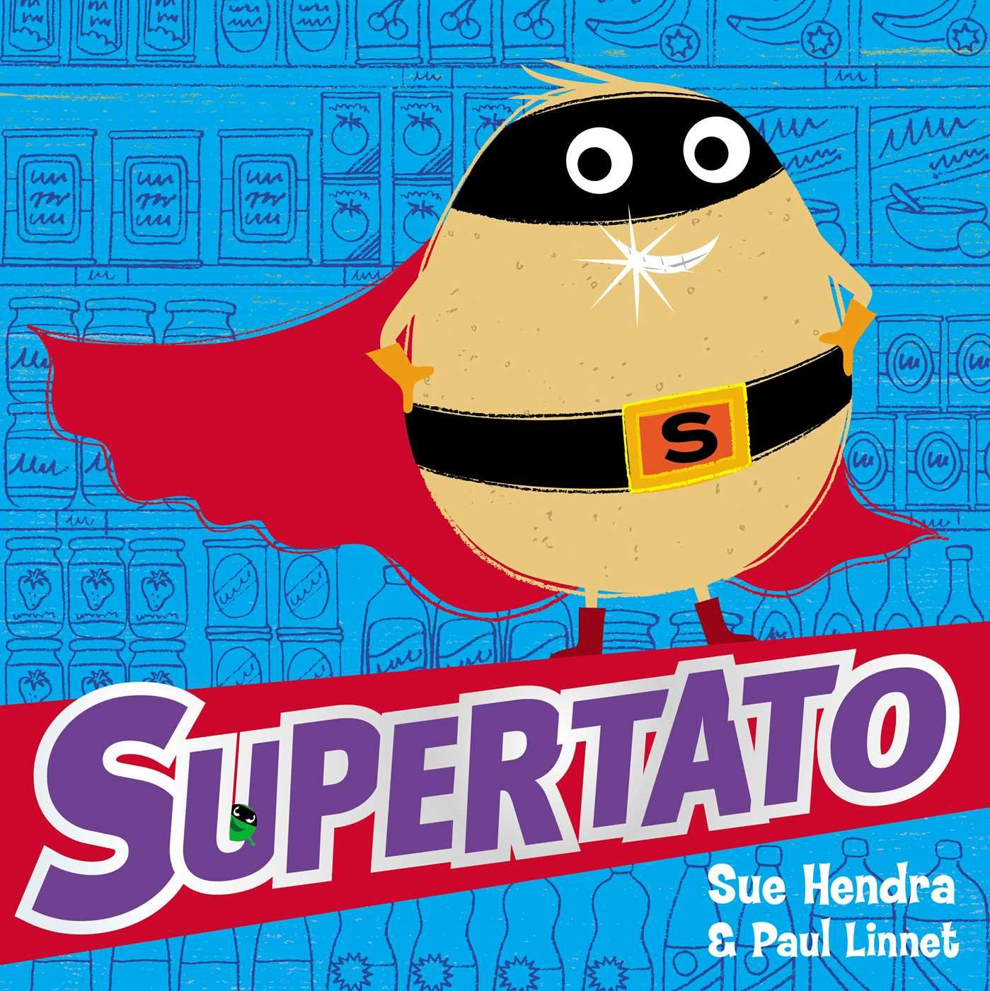

Monday 20th April

Activity 1: | Activity 2: | Activity 3:
Read Supertato if you have it or watch this reading on youtube https://www.youtube.com/watch?v=QlaMeNmTG6c&t=33s  (always with an adult present).  Talking Together: Use your maths skills to make a trap for the evil pea. Remember he is small so what might you have to make sure he doesn’t escape?  What could you use? A box? Remember we just want to trap him so he will need holes to breath! If you can’t make a trap, could you draw one? | Check in your freezer – do you have any peas in there? Are there any other frozen vegetables in there? How many different vegetables do you have? Are the bags full or half full?  Could you make a list of all your frozen veggies? Or you could make a list of all the vegetables that you and your family members like. | To continue to build hand muscles and work on fine motor skills at home there are a range of activities that you can do, including: practising pouring your own drink, zipping up your coats, doing up buttons, learning to tie your shoelaces, pairing socks to put away!  Make sure you are being independent and helping out your family by trying your hardest to do things like this.
Open this book Sun hat fun to read or be read to each day. Today have a look at Ditty 1 together.

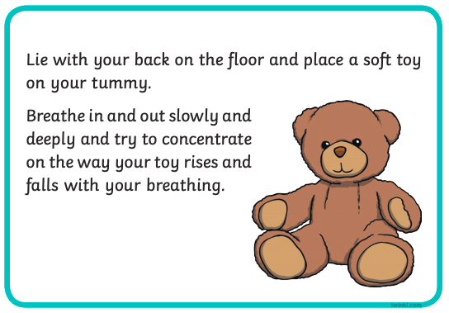

Take a moment for yourself. This is a lovely activity to do to enjoy a quiet moment. It will help you to calm down if you are feeling upset. Do this daily, or when you need to.
Tuesday 21st April

Activity 1: | Activity 2: | Activity 3:
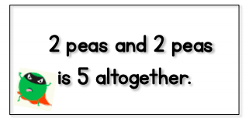  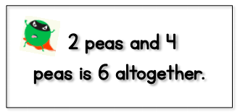  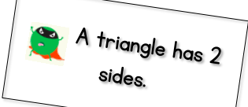  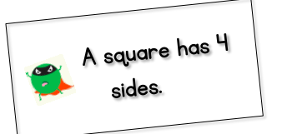  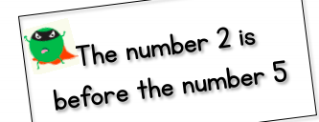  Talking Together:  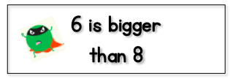  Here are some correct and incorrect pea maths for you to help Supertato teach the veggies! Can you tell your grown up why they are wrong or why they are right? | In the story “Supertato” the pea gets trapped in jelly! What other veggies or characters could you trap in jelly? Perhaps you could write the vegetable trapped in the jelly, or a sentence saying what is trapped in the jelly.  Parents: it can be written phonetically (how they hear the sounds)  E.g. caruts (carrots), pees (peas) unyun (onion!).  or  The brokolee is stuk in the jellee.  (The broccoli is stuck in the jelly). | 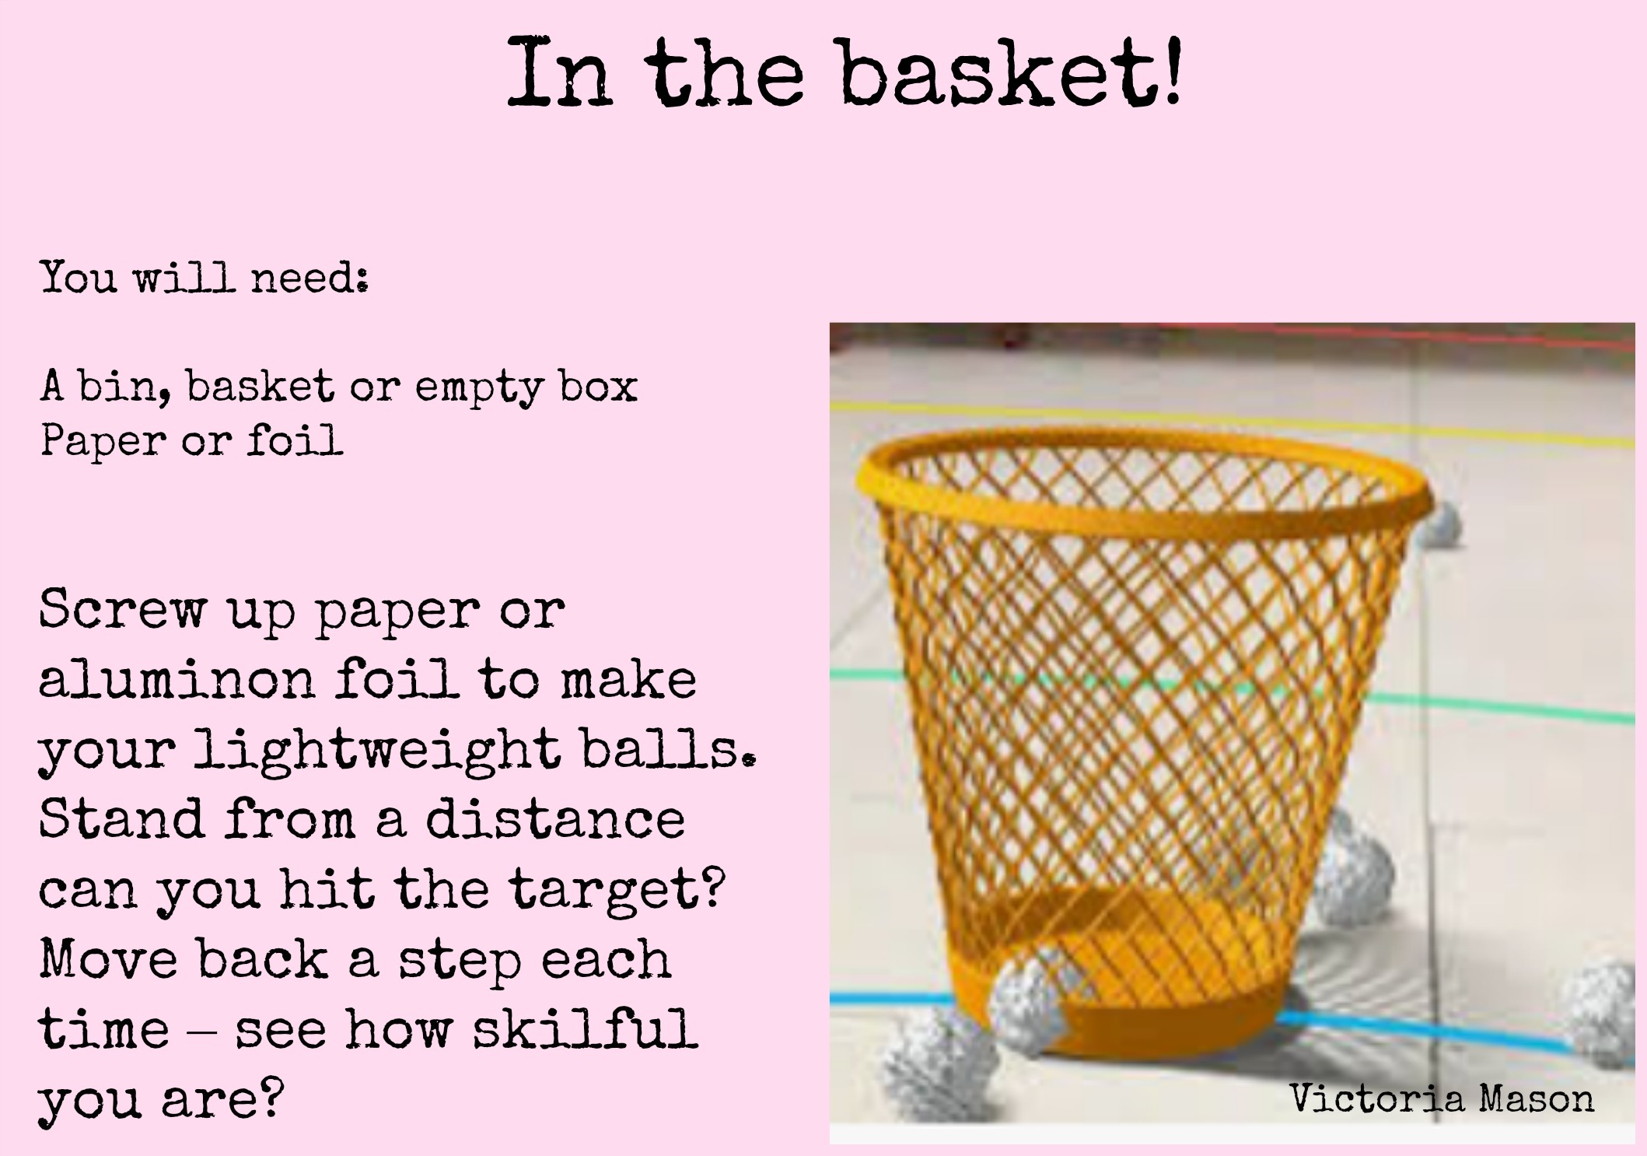  Screw up paper or foil to make balls. Stand back and see if you can hit the target! Move back a step each time you can hit it and see how skillful you are!  If you have five balls, throw them all at once. See how many land inside and how many outside. The total will always be five! It’s a good way to learn your number bonds to five.
Read Ditty 2 together and talk about the questions at the end of the story.

Your children love numberblocks! NCETM (national centre for excellence in the teaching of maths) also endorses ‘Numberblocks’ and you can find the episodes on CBeebies and youtube (always with an adult present). Numberblocks - CBeebies
Find the songs on here for your children to learn! Singing about ‘one’ may not seem tricky, but understanding ‘one’ is very important when you get to double and treble figures!!

Wednesday 22nd April

Activity 1: Set up a Veggie Race! | Activity 2: In your outside time | Activity 3:
Talking Together:  Have a look and assemble your veggies! What different kinds have you got? Who is going to compete in the race? Make your own racetrack! This could be a big one outside or a mini race for peas on the table. Have you got something for a finish line?  Take turns to roll each of your veggies or roll together with a grown up or someone else in your house. Who is the winner? Let us know the best rollers! | Race yourself! Why not use your time outside to set your own challenges just like the veggies. Their sports were Running, jumping and spinning!  Talking Together:  Set yourself some challenges. How many jumps on 2 feet can you do in a minute? Get a grown up to set their phone timer. How many on 1 foot? How many spins can you do? Don’t get dizzy! Can you run on the spot for one minute? | Go on a ‘sound’ scavenger hunt!  Supertato begins with ‘s’. Can you find ten things in your home beginning with ‘s’?  Perhaps you or a family member, with your help, can write a list.
Read Ditty 3 together and talk about the questions at the end of the story.

Have you been doing any exercise? You could try Andy’s Wild Workouts on CBeebies. Let us know how you get on!

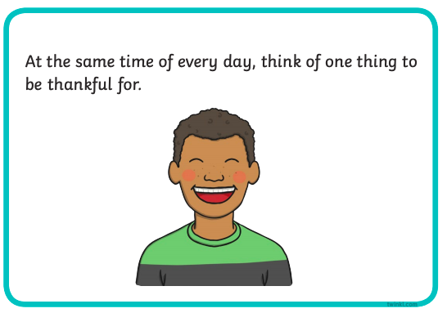
I do this everyday when I get up! It helps me to feel better about everything that is going on. Perhaps you are grateful because the sun came out. Maybe you are grateful because you have your favourite toy to hold. You can be grateful for having clean water to drink or having running water for your bath or shower!

Thursday 23rd April

Activity 1: | Activity 2: | Activity 3:
Do some potato printing. Have you got any old potatoes that are sprouting? Can a grown up help you cut them in half and print with them? Perhaps you could have two different shapes or sizes? Or even use two different pieces of old veg, like a wrinkly carrot! Can you make an AB pattern for example red blue, red blue, red blue; or circle square, circle square.  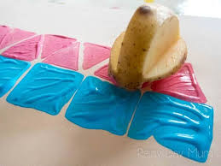  If you don’t have paint, perhaps you could design a repeating pattern by drawing shapes or get even more creative like this!  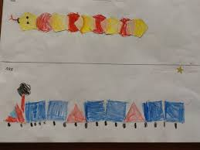 | Make a wanted poster for the Evil Pea! A grown up can help you draw the template.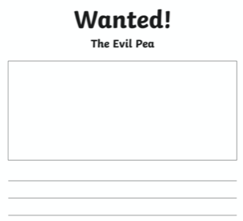  Think about what the pea looks like and write a description! Use words like small and green. | Go on an old photo hunt in your house. Ask someone o get out their old photos and talk about them to you. How have people changed? What was different when mummy and daddy were younger and when grandparents were younger? If you are video chatting with family members, perhaps they can tell you about their photos.
Read Ditty 4 together and talk about the questions at the end of the story.

Alphablocks is a Cbeebies children’s program which can support ‘Fred talk’ and blending of CVC words and beyond. You can watch episodes on Youtube (with an adult present) as well as downloading the free app: ‘meet the alphablocks’.

Friday 24th April

Activity 1: | Activity 2: | Activity 3:
Try a yoga session. Yoga will help you to strengthen your body and help you to relax so you can feel calm and concentrate on the day.  Cosmic Kids Yoga  This has different length sessions, shorter ones are better for younger children.  The Friends Flow!💞- Hey Duggee Yoga Part 1 - Hey Duggee  Hey Duggee does yoga too! These are short, about six minutes. | Talking Together:  Grown ups, can you supply paper, card/glue or whatever you can?  Make your own super vegetables.  Don’t forget your superhero cape! Give your super veggie a name.  Or…would you prefer your veggies to be evil like the pea – a villain!  Can you take a picture and list your veggie’s super powers. What might these be? For example,  1. Super squishing power.  2. Power to make people smile.  3. Super tickler! | If you were a superhero, what kind of superhero would you be? What would be your super powers?  Can you draw a picture of you as a superhero, or write about it? Or perhaps someone can make a video of you talking about being a superhero.  What superpowers would your superhero family have?
Did you know one of our favourite authors, Oliver Jeffers, is reading one of his stories every day? Check out https://www.oliverjeffers.com/abookaday

