Literacy
Last half term, we used a short film as our stimulus for writing. This half term, we will use a different film every two weeks. This week, you are going to be using a picture from the film. Next week, you will watch the whole film and then answer questions about it.

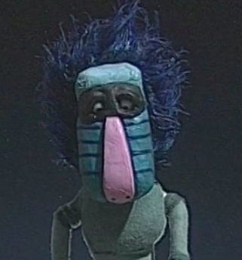

Activity 1:  First, let’s use our prediction skills. Look at the image and spend 2 minutes writing what you can see. How many adjectives can you think of to describe the character? What do you think he or she is called? Can you give them a name?  Then spend 2 minutes writing about how the character is feeling in the picture and why might they be feeling that way.  If you do this activity with your family, I wonder if they had the same thoughts and wonderings as you! | Activity 2:  What might the character be saying? Can you write some direct speech for them? Use the video below to remind you of the correct punctuation.  https://www.youtube.com/watch?v=6-YFmLctwDY  Where might the story be set? | Activity 3:  Write your own story featuring this character. It can be anything you want as we don’t know anything about the real story in the film yet.  Can you include:-  Adjectives (these describe a noun) such as strange, upset, hairy.  An adverb:- (these are our ‘ly ly girl’ words) such as sadly, joyfully.  Challenge: Can you include a fronted adverbial?  https://www.bbc.co.uk/bitesize/topics/zwwp8mn/articles/zp937p3  (eg: After he woke up, he went outside.)
NS: After you have written your story, read them again. Edit and improve your writing, like we do at school!
- Additions (adding in missing words or phrases)
- Revisions ( improving sentences or word choices )
- Corrections (correcting wrong spellings)

Spellings
Practise spellings for the words below. Use your neatest handwriting to write them in sentences.
accident accidentally actually address answer appear arrive
Challenge: If you don’t know any of the meanings, can you find them out using an online dictionary?

Reading
Reading, reading, reading - it is the most important skill you will ever learn! Keep up with your daily reading, whether it is a comic, facts on a website, non-fiction or fiction books or a letter from a friend.

Story time from space
This website is out of this world! Astronauts on the International Space Station read a wide range of stories. https://storytimefromspace.com/library/
OR, why not try https://www.storylineonline.net where people who work in film and television read their favourite stories to you.

Writing
The National Literacy Trust has made a family zone with links to lots of exciting sites focused on writing and reading. One of the Year 3 and 4 teachers’ favourites is Michael Rosen reading his poetry and stories because he reads with such a range of expression, making funny voices and silly faces!
https://literacytrust.org.uk/family-zone/5-8/

Flash academy offers lots of different videos covering different subjects, but we enjoy the grammar videos to challenge us and make our writing even better! Can you find the videos about proper nouns, conjunctions and prepositions? See if you can remember what they are before watching the videos.
https://flashacademy.com/grammvideos

Maths
Please use the White Rose Maths resources where you will find daily activities and videos to support. The learning is organised in weeks. Please start with Summer Term week 1 BUT if you want to challenge yourself, you can also go back and complete Week 1 and 2 from before Easter if you haven't seen these already:

Year 3 - Miss Paxman’s group
https://whiterosemaths.com/homelearning/year-3/

Year 4 - Ms Chicken’s group
https://whiterosemaths.com/homelearning/year-4/

Miss Timlin’s Group
Pick a link from either Year 3 or Year 4 above.
Challenge:- You can try to complete both ……….

In Year 3, the expectation is that children know the 2, 3, 4, 5, 8 and 10 times tables in order, muddled and quickly by the end of the year. If you need an extra challenge, the next step is 6 times tables.
In Year 4, all children need to be fluent in all times tables up to 12 x 12 . Use the link below to practise.
https://www.timestables.co.uk

Science
In science we have been studying sound.Watch the video from House of Sound again.
https://www.youtube.com/watch?v=En4Wlojjgxk

Activity:
AS a reminder, listen to the different sounds in your house. How many can you record in 10 minutes? Which sounds are the loudest? Which are the quietest?

Topic - Music from around the world

This half term we will continue to study music from around the world and the famous composers who wrote it. This week, we will be learning about Ludvig Von Beethoven. Watch the video about perhaps his most famous piece of work. Have you heard it before?

https://www.youtube.com/watch?v=MCqmfHLGa_4

Activity 1  Think of 5 adjectives to describe him.  Why do you think he is still so famous today? | Activity 2  How did the music make you feel - can you describe it?  Maybe you could draw a spider diagram and write down all the words to describe your feelings. | Activity 3  CHALLENGE  Use the internet to research more about Beethoven then write a fact file about him. Include information such as his family, his work, where he lived and when he lived and died.  OR  Find five interesting facts about Beethoven

PE
Although it is really important to make sure you are still doing your learning, it is just as important to look after your bodies and to keep them healthy!
This week have a go at some of these 60 second challenges:
https://www.youthsporttrust.org/60-second-physical-activity-challenges
How many star jumps can you do in 60 seconds?
How many times can you throw a ball in the air and catch it?
Miss Paxman’s record for the star jump challenge is 56… who can beat it?!

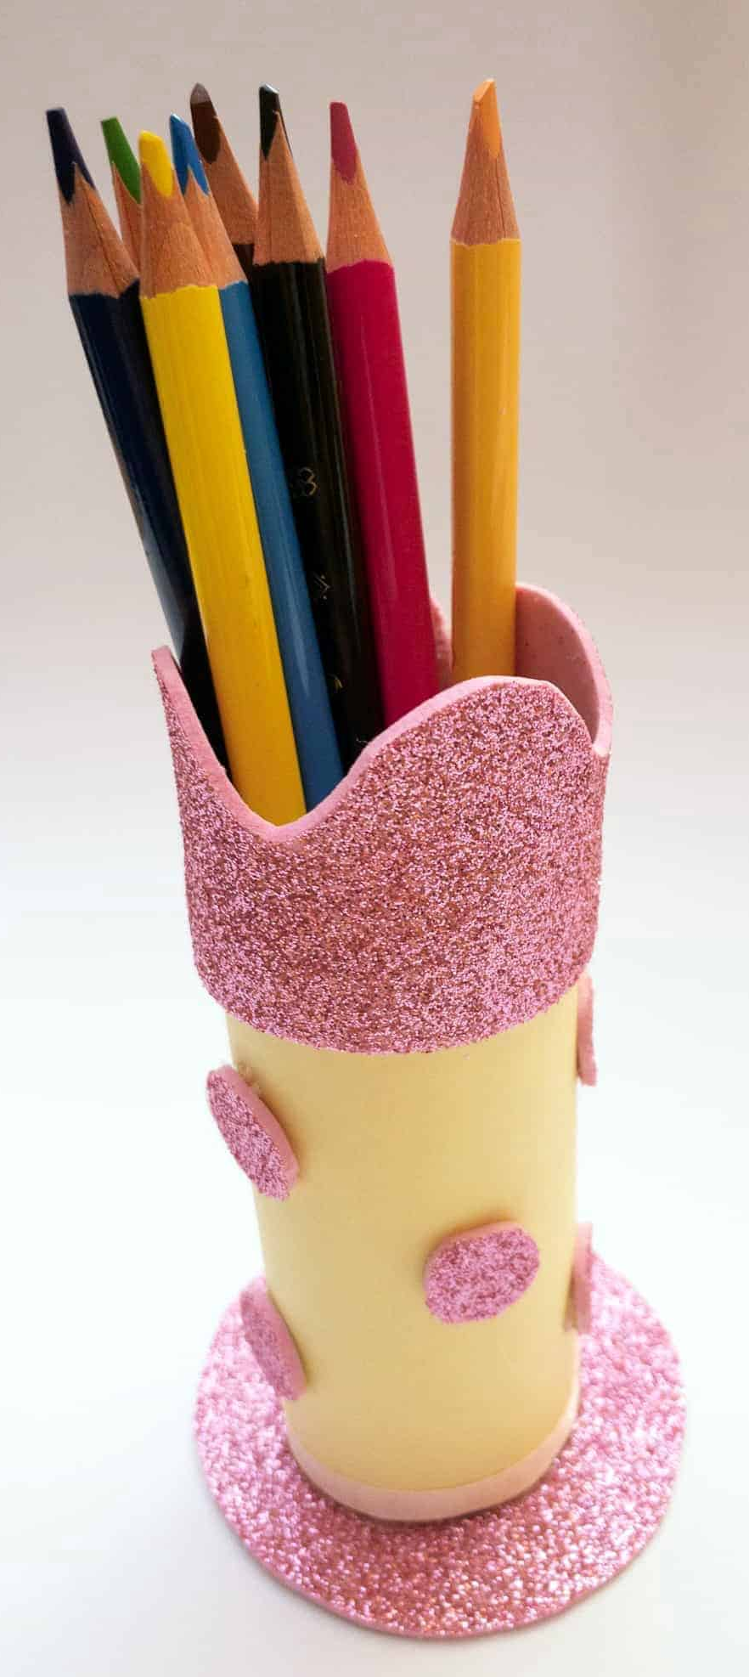
Craft: Use all of those empty toilet rolls to make yourself a pencil holder for when you are doing your home learning!
Your will need: Toilet paper roll, colouring pens, glue or sellotape, card and any extra things you have lying around at home (stickers, paint, coloured paper)
Step 1: Decorate your toilet roll!
Step 2: Glue or tape the bottom of the toilet roll onto a hard piece of card
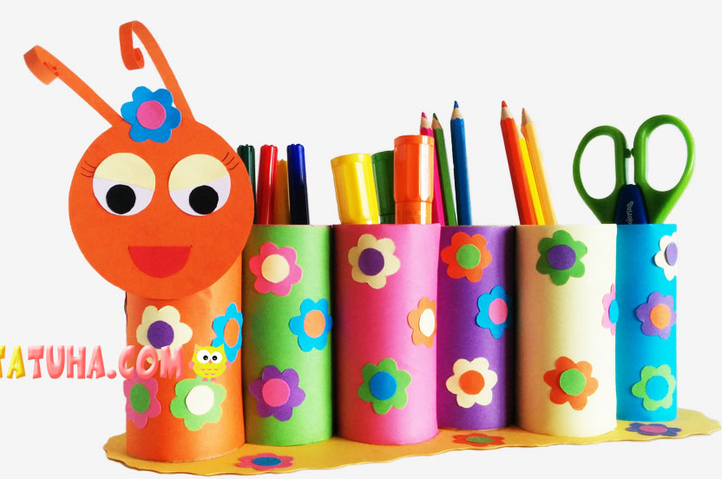
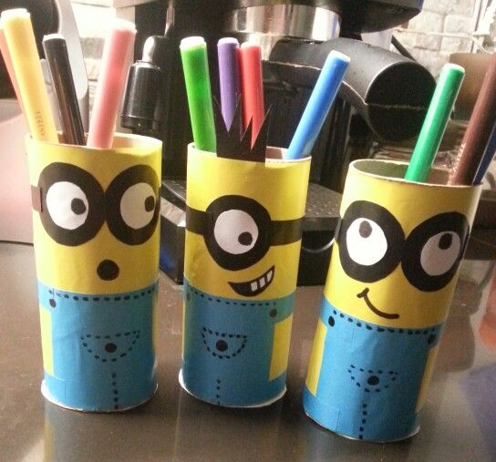
Step 3: Wait for it to dry and fill it up with your pencils and pens!

Religious Education
Easter was a very important time for Christians around the world – although this Easter was very different as many church services took place online! Use the link below to watch a video and then answer questions about Easter. How does Easter compare to festivals in your religion?
https://www.natre.org.uk/uploads/Free%20Resources/1%205-7%20RE%20Today%20and%20NATRE%20home%20learning%20Easter.pdf

