Literacy
Last half term, we were learning about Paddington Bear, where we described different teddy bears using a range of adjectives. Let’s use our creativity to write about this story:
What the Ladybird Heard https://www.youtube.com/watch?v=Eu9mPX7DuLA
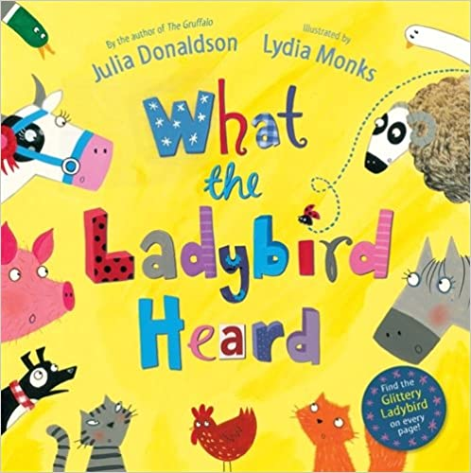

Activity 1: | Activity 2: | Activity 3:
- Look closely at the picture. Draw or write what you can see.  - Say what you think will happen in the story.  - Draw pictures and write the names of all the farm animals you know. | A ladybird lived on a farm and she heard...  - Finish the sentence about what she heard  Example:  A ladybird lived on a farm and she heard a cow say moo.  - Write 4 sentences to describe Lanky Len and Hefty Hugh.  Example:  Lanky len is tall and mean.  Challenge your family to do the same, how many different ways can you describe the characters? | - Draw a story map to tell what happend  - Retell the story with actions using:  - A ladybird’s whispering voice  - The voices of the animals  ----------------------------------------  Can you rewrite the story in your own words?  Use adjectives to describe nouns (people, places or things):  kind quiet sly cunning naughty  helpful brave

Spellings
Practise these spellings. Use your neatest handwriting to write them in sentences.
now, how, brown, down, town, out, about, mouth, sound, you

Phonics and reading
Reading, reading, reading - it is the most important skill you will ever learn! Keep up with your daily reading, whether it is a comic, facts on a website, non-fiction or fiction books or a letter from a friend.
Phonics Play
This site usually has some free games, but they have made it completely free.
www.phonicsplay.co.uk Username: march20 Password: home
Story time from space
This website is out of this world! Astronauts on the International Space Station read a wide range of stories. https://storytimefromspace.com/library/

Writing
The National Literacy Trust has made a family zone with links to lots of exciting sites focused on writing and reading. Have a look at Michael Rosen reading his poetry and stories because he reads with such a range of expression, making funny voices and silly faces!
https://literacytrust.org.uk/family-zone/5-8/

Maths
Please use the White Rose Maths resources where you will find daily activities and videos to support. The learning is organised in weeks. Please start with week 1: https://whiterosemaths.com/homelearning

In Year 1, the expectation is that children can count in multiples of 2, 5 and 10 and can recall and use all doubles to 10 and their corresponding halves.
https://www.timestables.co.uk/

Science
Activity 1 - Plants
- Can you name any plants you have in your garden or when you are out on a local walk? Can you draw them and talk about how they are different to each other?
- Collect pieces of fruit. What do they look like? What do they smell like? What do they feel like? What do they taste like? Why not try planting some fruit seeds!

Activity 2 - Materials
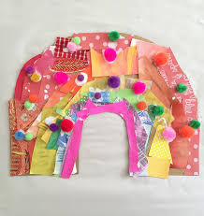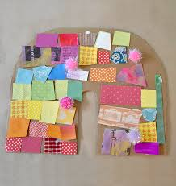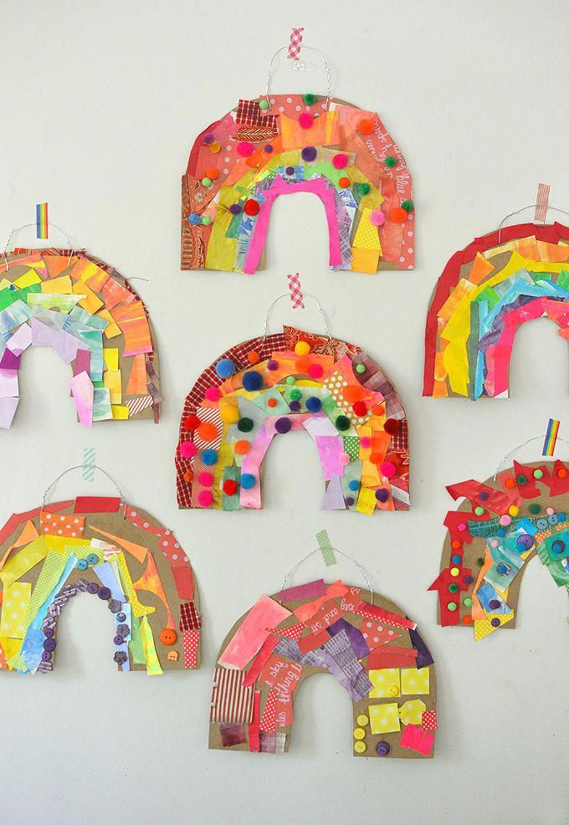
Material rainbow
Gather different coloured materials together. Can you collect materials that are every colour of the rainbow? Cut out different colours from magazines.
Ask an adult which materials you can use to create a textured rainbow collage to display in your window.

Activity 3 - Materials
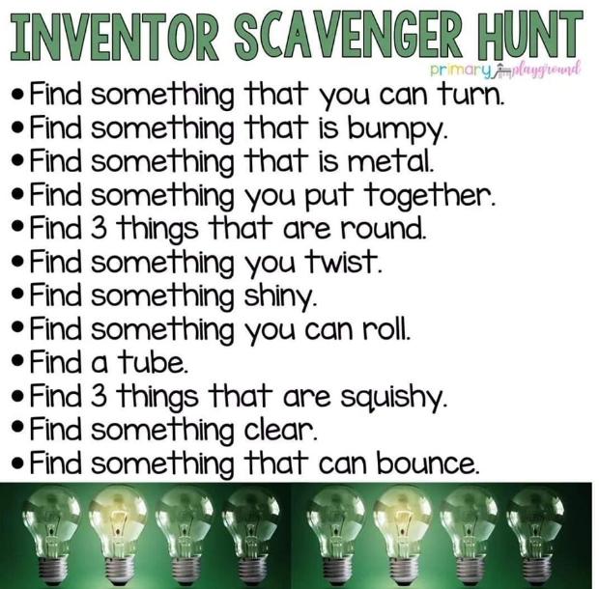

Topic - Down at the bottom of the Garden
What minibeasts can you find in your garden or in a local green space? Can you draw them and find out about them? Please be careful to put back anything you collect or move when looking for minibeasts.
Show what you have learnt about them by making a fact file, a poster or a quiz about the minibeast you think is most interesting.

Craft
There are lots of things to watch, do and make on the Little Angel Theatre website. https://littleangeltheatre.com/schools-and-community/at-home-resources/?utm_campaign=1723741_Online%20activities%20-%20for%2011x11%20schools&utm_medium=email&utm_source=littleangeltheatre&dm_i=2U8A,10Y1P,7HH9YG,3WJ3O,1

