Dear Nursery and Reception children,
We hope that you are feeling well and are enjoying your time with your family and we also hope that are showing that you are showing and sharing our Pooles Park values at home:
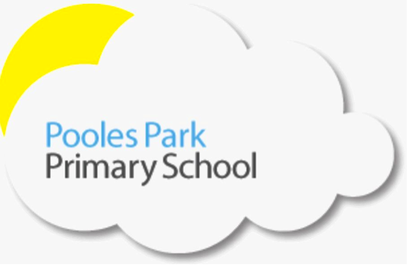We are responsible We are respectful We are ready

We are very proud of you all for being so brilliant at this challenging time. You might think that your teachers are enjoying this quiet time, but in fact we miss you so much and miss seeing your smiling faces every day! But we are happy that you are all staying safe and keeping other people safe and healthy too.

Dear Parents and Carers,
Thank you for all of your support during this very unusual time. We hope that you are managing to enjoy the extra time with your families.

We will be uploading new home learning to the website every week. This week, there are literacy and maths activities as well as links to wider curriculum learning. Please don’t feel pressured to complete everything perfectly, if it is not possible to do this due to your home / work situation, then please do as you see fit. We are working hard to create learning packs and recommend websites to further your child’s learning but please also take time to chat, play, build forts, dance and sing together!

In addition, the government has unveiled a new package to support home learning under the name of the Oak National Academy from April 20th. It will include video lessons each week. Find out more here: https://www.thenational.academy/ and here: https://www.gov.uk/government/news/new-major-package-to-support-online-learning. The BBC is also delivering learning resources across BBC iPlayer, Red Button, Bitesize, Radio 4 and BBC sounds from April 20th. Find out more here: https://www.bbc.co.uk/mediacentre/latestnews/2020/coronavirus-education.

Stay healthy, happy and safe at home, we can’t wait to see you all again soon!
Mrs Laurnagaray, Miss Dargiel, Miss Mina, Miss Begum, Miss Marra, Miss Naz and Mrs Corrick

