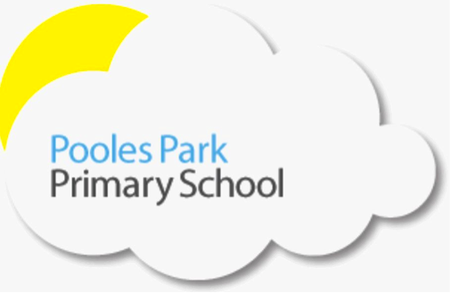We are responsible We are respectful We are ready

Dear Nursery and Reception children,
We hope you are enjoying time with your family and are making the most of the sunshine. We are missing you very much and have enjoyed speaking to some of your parents this week to find out what you’ve been up to. If you haven’t heard from us yet, we will be in touch very soon. Stay safe and keep smiling!

Dear Parents and Carers,
Thank you for all of your support during this very unusual time. We hope that you are managing to enjoy the extra time with your families.

We will be uploading new home learning to the website every week. This week, there are literacy and maths activities as well as links to wider curriculum learning. Please don’t feel pressured to complete everything, if it is not possible to do this due to your home / work situation, then please do as you see fit. Please also take time to chat, play, build forts, dance and sing together! We’d love to see what you’re up to please use Tapestry to upload photos and videos. Email admin@poolespark.islington.sch.uk if you have any questions about this.

In addition, the government has unveiled a new package to support home learning under the name of the Oak National Academy from April 20th. It will include video lessons each week. Find out more here: https://www.thenational.academy/ and here: https://www.gov.uk/government/news/new-major-package-to-support-online-learning. The BBC is also delivering learning resources across BBC iPlayer, Red Button, Bitesize, Radio 4 and BBC sounds from April 20th. Find out more here: https://www.bbc.co.uk/mediacentre/latestnews/2020/coronavirus-education.

Stay healthy, happy and safe at home, we can’t wait to see you all again soon!
Mrs Laurnagaray, Miss Dargiel, Miss Mina, Miss Begum, Miss Marra, Miss Naz and Mrs Corrick

Follow this link to YouTube, where Mrs Corrick will read you a story https://www.youtube.com/watch?v=_YLDDK5tSnc&feature=youtu.be

