Calendar - stick somewhere handy
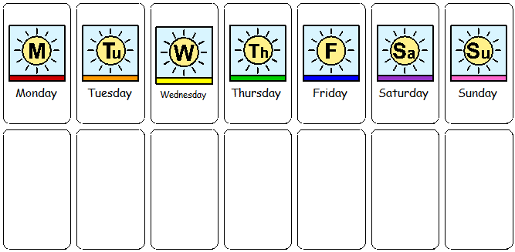

Calendar - stick somewhere handy
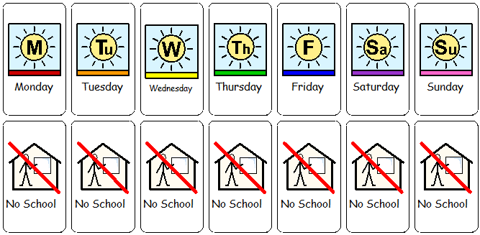

Calendar - stick somewhere handy
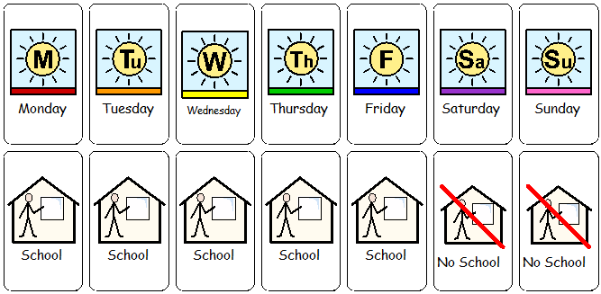

Calendar - stick somewhere handy

