POOLES PARK’S COMMUNITY GARDEN IS OPEN THIS MARCH 2020
Our garden is a beautiful, mini oasis for ‘Wildlife and Us’.
Please come along and help us with our seasonal, nature-care activities or just simply pop in and enjoy this local, peaceful and uplifting green space
At
POOLES PARK PRIMARY SCHOOL, LENNOX ROAD, FINSBURY PARK, N4 3NW
Entry is through the garden gate on Hatley Road
12 – 4pm

0n:

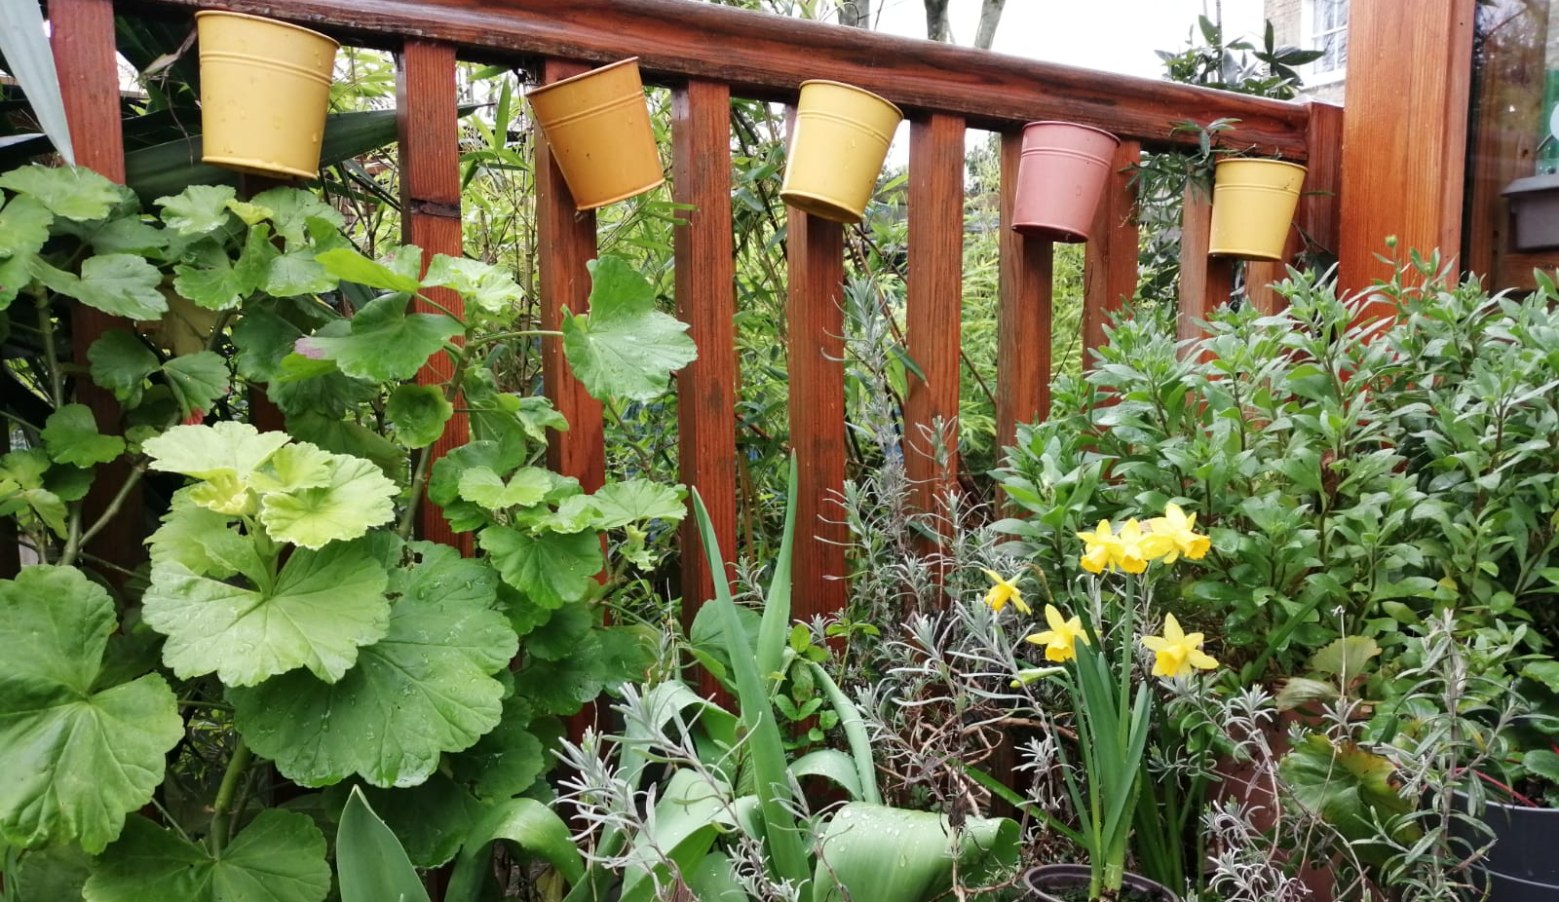

SATURDAY 14th MARCH

& SATURDAY 28th MARCH

Please note: Children must be accompanied by an adult

Our project ‘Naturehood for our Neighbourhood’ is funded by Islington Council’s Community Chest.
'Islington Council’s Community Chest is funded by Islington Council, in partnership with the Cripplegate Foundation’

