EYFS Home Learning
Whilst your children are not at school, they will benefit from a clear daily routine, including activities that will support their home learning.
Please find following a useful list of websites covering a wide range of activities that will include activities appropriate to EYFS. We have also attached a sheet with a variety of activities that you can do at home with your child.
The imagination tree has suggested following this simple daily routine:
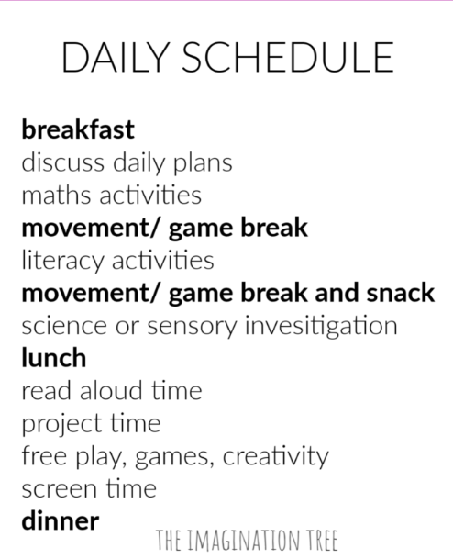
Islington Bright Start are encouraging you to sign up for their newsletter on http://bit.ly/BSBIsubscribe
https://abcdoes.com/abc-does-a-blog/2020/03/14/at-least-50-fantastic-ideas-to-try-at-home/; a bank of ideas drawn together by Alistair Bryce Clegg with practical activities that can easily be done at home and is updated every week.
https://theimaginationtree.com/stay-at-home-survival-guide/. The imagination tree website has been developed by an EY teacher and parent of 4 young children with planning, play and learning ideas for self-isolation. It has a selection of lovely ideas that stress the importance of keeping things as playful, fun and as active as possible
https://hungrylittleminds.campaign.gov.uk/. Hungry Little Minds, the DfE webite, has activities broken down by age with a ‘chat, play, read’ emphasis. There are accompanying video clips and links to other sites and apps.
https://www.bbc.co.uk/tiny-happy-people has communication focussed ideas, broken down by age with the tagline ‘talk, bond and have fun’.
There is support on social media; you can encourage join the facebook page; ‘Family lockdown tips and ideas’. This is a page for parents full of tried and tested ideas, games and activities. Instagram’s ‘fiveminutemum’ has easy fun games for parents to play with their young children.
These further sites cover a wide range of subjects and activities. You may need to sign up to create a free account to use some of the resources.
PE / Dance / Mindfulness
Go noodle: https://app.gonoodle.com/
Maths, English, Topic
Mathseeds (children have a log in for this) https://mathseeds.co.uk/
Lgfl (children have a log in for this) https://www.lgfl.net/default.aspx
Twinkl (includes activities and resources to support all areas of learning) https://www.twinkl.co.uk/search?term=school+closure
BBC Bitesize https://www.bbc.co.uk/bitesize/levels/z3g4d2p
Oxford Owl (for a variety of online books to read) https://www.oxfordowl.co.uk/for-home/
First news child newspaper https://www.firstnews.co.uk/
Games linked to learning
Busy things: https://www.busythings.co.uk/
Topmarks https://www.topmarks.co.uk/

